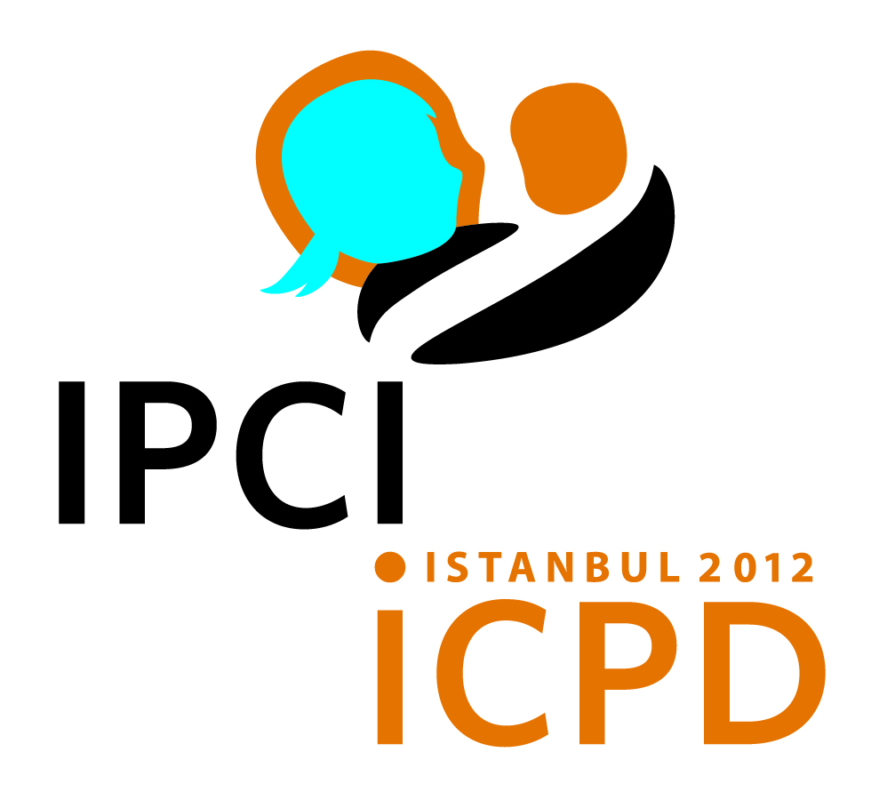
THE 2012 INTERNATIONAL PARLIAMENTARIANS’ CONFERENCE ON THE IMPLEMENTATION OF THE
ICPD PROGRAMME OF ACTION

DRAFT AGENDA

Wednesday, 23 May 2012

10:00-22:00 Registration

16:00-16:45 Briefing For Resource Persons and Rapporteurs of the Group
Discussions

18:00-19:00 Steering committee meeting

19:00-20:00 Drafting Committee Meeting

Thursday, 24 May 2012

8:00-12:00 Registration (continued)

Master of Ceremonies: Ms. Safiye Cagar, Director of Information and External Relations, UNFPA

Mr. Neil Datta, Secretary, European Parliamentary Forum on Population and Development

9:00-10:00 Opening Ceremony
Chair: Hon. Baroness Jenny Tonge, EPF Vice President, Chair of the UK APPG

- Welcoming Remarks
- Hon. Mrs. Öznur Çalık, MP, Chair of the Turkish Parliamentary Group on Population and Development of the Grand National Assembly of Turkey and Executive Committee Member of the European Parliamentary Forum on Population and Development, EPF

- Hon. Mr. George Tsereteli, MP, President, European Parliamentary Forum on Population and Development, EPF and Vice-Speaker of the Parliament of Georgia

- Keynote speeches
- H.E. Mr. Cemil Çiçek, MP, Speaker of the Grand National Assembly of Turkey

- Group Photo

10:00-10:30 Coffee Break

10:30-11:30 Opening Session
Chair: Hon. Mr. George Tsereteli, MP, President, EPF and Vice-Speaker of the Parliament of Georgia

- Purpose of the Conference
Ms. Safiye Çağar, Director, Information and External Relations Division, UNFPA

- Keynote Address
Dr. Babatunde Osotimehin, Executive Director, UNFPA

- Special Guest Statements
- Hon. Ms. Carolyn Maloney, Congresswoman, US House of Representatives

- H.E. Mr. Christian Friis Bach, Minister for Development Cooperation, Denmark

- H.E. Mr. Cevdet Yılmaz, Minister of Development of Turkey

- Election of Officers
Chair, Steering Committee

- Election of Drafting Committee Members
Chair of the Conference

11:30-13:00 Session 1
Chair: Ms. Danielle Bousquet, MP, France, EPF Vice President
Special Panel Discussion: Origins of the ICPD Cairo Agenda: The Past
Panelists (7-10 minute presentations and Q & A):

ICPD's visionary agenda and outcome -relevance for future sustainable development - Dr. Fred Sai, Ghanaian Physician and Family Planning Advocate

Scaling up strategies to reduce maternal death: achievements and persistent challenges - Dr. Gamal Serour, Professor of Obstetrics & Gynecology, Al Azhar University, Egypt

Bridging the Gaps- Ms. Carmen Barroso, Regional Director, International Planned Parenthood Federation/Western Hemisphere Region

13:00-14:30 Lunch hosted by H.E. Prof. Ahmet DavutoĞlu, Minister of Foreign Affairs of Turkey

14:30-16:00 Session 2
Chair: Hon. Mrs. Öznur Çalık, MP, Chair of the Turkish Parliamentary Group on Population and Development of the Grand National Assembly of Turkey and Executive Committee Member of EPF
Special Panel Discussion: Status of the ICPD Agenda: The Present
Panelists (7-10 minute presentations and Q & A):

Eliminating Maternal Death and Disability-
Mrs. Sandra Elizabeth Roelofs, First Lady of Georgia

Role of Parliaments in finding solutions towards a sustainable future-
H.E. Ms. Rebecca Kadaga, Speaker of Parliament, Uganda

Addressing demographic diversity – persistently youthful populations and rapidly ageing populations, meeting the challenges of investment in human capital and promoting intergenerational solidarity –
Mr. Andrew Mason, University of Hawaii, Professor, Senior Fellow in Population and Health Studies, East-West Center

Getting more out of global health partnerships in advancing the ICPD mandate- Ms. Gita Sen, Adjunct Professor of Global Health and Population, Department of Global Health and Population, Harvard School of Public Health

16:00-16:30 Coffee Break

16:30-18:00 Session 3
Group Discussions – approx. 30-40 parliamentarians in each group
Recommendations for ICPD beyond 2014 and outcome document

- Mobilising the Necessary Resources for the ICPD

- Strengthening Parliamentary Oversight in the Implementation of the ICPD agenda

- Legislation and the implementation of the ICPD

- Understanding and managing the politicisation of the ICPD agenda

- Building Partnerships and Networking for the ICPD mandate

- Communication as a critical tool for forging shared understanding and cultivating public support on the ICPD

- Mechanisms for follow-up on national, regional and global action plans and commitments

- Gaining of experiences of past champions and preparing the next generation of ICPD supporters

18:00 - Closing Of Day 1
Chair of the Conference
EPF Awards: Recognising remarkable successes in the Population and Development field

19:00-20:30 Dinner hosted by H.E. Mr. CEMİL ÇİÇEK , Speaker of the Grand National Assembly of Turkey

21:00-23:00 Drafting Committee Meeting

Friday, 25 May 2011

8:00-8:45 Drafting Committee Meeting

9:00-10:30 Session 4
Chair: Ms. Yvonne Gilli, MP, Switzerland, EPF Executive Committee Member
Special Panel Discussion: Way forward for the ICPD Agenda: The Future
Panelists (7-10 minute presentations and Q & A):

Civil society role in implementing the ICPA agenda as part of the next development framework: concrete steps - Mr. Tewodros Melesse, Director-General, International Planned Parenthood Federation

Role of lawmakers in using the ICPD Programme of Action to shape the discussions of the post-2015 development frameworks – Hon. Ms. Rathika Sitsabaiesan, MP, Canada

What does it take to empower the young people to create a better world for their future - Mr. Alex Wirth, Member U.S. National Commission for UNESCO, USA

10:30-11:00 Coffee Break

11:00-12:30 Session 5
Group Discussions – approx. 30-40 parliamentarians in each group

- HIV/AIDS
Resource Person: Mr. George Tembo, Chief, HIV and AIDS Branch, UNFPA

- Youth
Resource Person: Mr. Angga Dwi Martha, Youth Advocate, Indonesia

- Gender and Education
Resource Person: Ms.Ann Van Lancker, Gender Advisor, UNFPA Regional Office for Eastern Europe and Central Asia

- Maternal health
Resource Person: Ms. Jill Sheffield, President, Women Deliver

- Family Planning

Resource Person: Mr. John Cleland, Professor of Medical Demography, London School of Hygiene and Tropical Medicine

- Climate Change
Resource Person: Mr. Werner Haug, Director, Technical Division, UNFPA

- Ageing/Low Fertility
Resource Person: Ms. Siri Tellier, External lecturer, Copenhagen School of Global Health, University of Copenhagen

- Migration
Resource Person: Mr. Francois Farah, Coordinator, Millennium Development Goals Task Force

12:30-14:00 Lunch hosted by H.E. Mr. Recep AkdaĞ, Minister of health of Turkey

14:00-15:00 Session 6
Presentation of the Outcome of Discussion by Each Group
Chair: Ms. Öznur Çalık, MP, Chair of the Turkish Parliamentary Group on Population and Development of the Grand National Assembly of Turkey and Executive Committee Member of EPF

Presentations by Chairs of the Group Discussions

15:00-16:00 Session 7
Discussion on the Draft Statement of Commitment
Chair: Baroness Jenny Tonge, EPF Vice President, Chair of the UK APPG
Introduction of the Draft Statement by: Chair, Drafting Committee

16:00-17:00 Session 8
- Adoption of the Statement of Commitment
Chair: Baroness Jenny Tonge, EPF Vice President, Chair of the UK APPG

- Discussion on Follow-up
Ms. Safiye Çağar, Director, Information and External Relations Division, United Nations Population Fund, UNFPA

Mr. Neil Datta, Secretary, European Parliamentary Forum on Population and Development, EPF

17:00-17:30 Coffee Break

17:30 Closing Session
- Closing Remarks
- Hon. Ms. Öznur Çalık, MP, Chair of the Turkish Parliamentary Group on Population and Development of the Grand National Assembly of Turkey and Executive Committee Member of the European Parliamentary Forum on Population and Development, EPF

- Hon. Mr. George Tsereteli, MP, President, European Parliamentary Forum on Population and Development, EPF and Vice-Speaker of the Parliament of Georgia

- Dr. Babatunde Osotimehin, Executive Director, UNFPA

- Remarks by Honoured Guest

- H.E. Mr. Recep Tayyip Erdoğan, Prime Minister of Turkey

20:00 Dinner (Boat Cruise) hosted by the Turkish Parliamentary Group on Population and Development of the Grand National Assembly of Turkey and with the Participation of H.E. Ms. Fatma Şahin, Minister of Family and Social Policies of Turkey

