Policy on Disclosure of NEX Audit Reports

Background:
- In accordance with the terms of the standard form of agreement entered into between UNFPA and its implementing partners (“Implementing Partner Agreement” or “IP Agreement”), implementing partners agree that their activities under the IP Agreement and any supplementary work plans are subject to audit. Such audits are conducted by auditors designated by UNFPA, or exceptionally by the Government’s supreme audit institution (“SAI”) where national legislation so requires.

- Occasionally, donors wish to review the audit report prepared on the activities of the IP under the relevant IP Agreement and workplans (“NEX audit report”) to which the donor contributed financially by way of co-financing (earmarked contributions). To this effect, donors contact a UNFPA office (Liaison office, RMB or global, regional, country office).
Policy:
- This policy establishes the following:
  - all requests for the disclosure of NEX audit reports to UNFPA donors must be processed promptly and efficiently according to the procedures established below; and
  - written agreement of the implementing partner (“IP”) to disclose the NEX audit report is duly obtained
  - NEX audit reports may be disclosed to a donor only when the following conditions (see Figure 1) are fulfilled:
- The donor provided substantial co-financed funding for the IP through UNFPA exceeding USD100,000 in a given year. The donor has submitted a written request form (Annex I), signed by an authorized official.
- The IP has submitted written consent form (Annex II), signed by an authorized official.
- Where the NEX audit report was produced or commissioned by an SAI, the SAI and/or the Government IP will usually hold all proprietary rights to the NEX audit report and have to consent to its disclosure. In these cases, additional disclosure requirements might apply under national regulations.

- Definitions:
  - “receiving office”: the UNFPA office who receives the request from the donor and is responsible for liaising with the donor
  - “managing office”: the UNFPA office working directly with the implementing partner and managing the activities for which the report is requested. The managing office may also be the receiving office in which case the below procedure applies accordingly.
Procedure:
- The donor contacts the “receiving office” to request a NEX audit report
- The “receiving office” confirms the conditions above have been met
- The “receiving office” contacts the “managing office” for assistance in obtaining consent of the implementing partner using the form in Annex II.
- The “managing office” provides the completed written consent form and the audit report to the receiving office.
- The “receiving office” continues to liaise with the donor. When submitting the NEX audit report to the donor, the “receiving office” must copy the DMS, IERD and DOS directors, chiefs of the NEX Unit, and RMB, and the “managing office”. The NEX Unit will maintain up to date data of all disclosure requests received, approved and denied.
Figure 1:
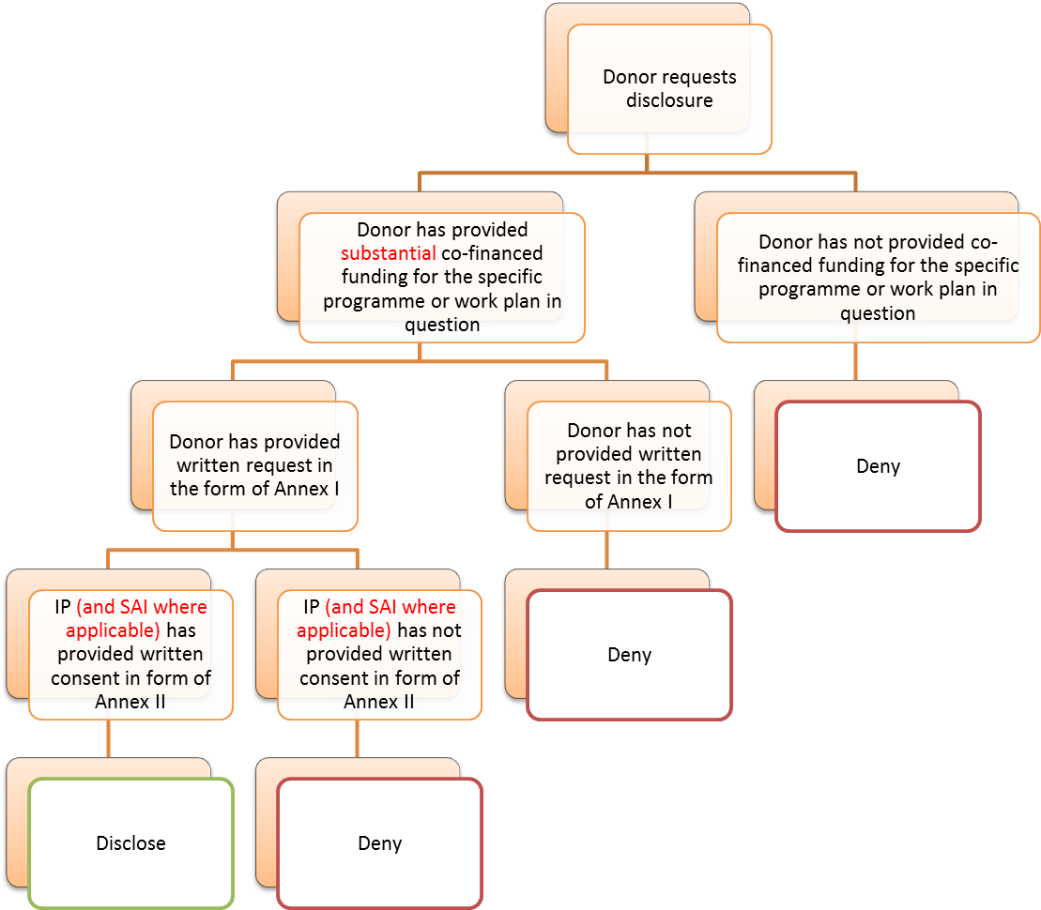

Annex 1 Standard Form for Request by Donor for Disclosure of NEX Audit Report

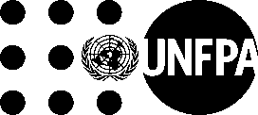
Name of Donor: [enter name of donor] (“Donor”)
Title of Co-financing Agreement: [enter title]
Date of Co-financing Agreement: [enter date]
Name of Implementing Partner: [enter name of IP] (“IP”)
Donor herewith requests UNFPA to disclose to it the audit report prepared on IP’s activities (“NEX audit report”) under the UNFPA programme of assistance for which Donor provided co-financed (earmarked) funding. Donor understands that the NEX Audit Report concerns IP’s activities and that IP’s consent is necessary for the requested disclosure. UNFPA, for the convenience of Donor, will forward Donor’s request to IP and request IP’s consent to the disclosure.
Signed for and on behalf of Donor:

Name: __________________________

Title: ___________________________

Date: _____________

Annex 2 Standard Form for Disclosure of NEX Audit Report
To be concluded by UNFPA:
[Enter full name of donor] (“Donor”) has requested UNFPA to disclose to it the audit report produced by [enter full legal name of auditors] dated [date of audit report] (“NEX Audit Report”) of the activities performed by [enter full name of IP] (“Implementing Partner” or “IP”) under the Letter of Understanding concluded between the United Nations Population Fund (“UNFPA”) and IP, which took effect on [enter effective date of LOU]. Given that Donor provided co-financed (earmarked) funding to UNFPA towards the implementation of the relevant parts of the UNFPA programme of assistance, UNFPA desires to make the requested disclosure of the NEX Audit Report to Donor. UNFPA requests IP to voluntarily consent and agree to above stated disclosure.
Signed for and on behalf of UNFPA:
Name: __________________________
Title: ___________________________
Date: _____________

To be concluded by IP:
IP confirms that it has been provided a copy of, and has reviewed the NEX Audit Report. IP herewith voluntarily consents and agrees/does not agree to the disclosure of the NEX Audit Report by UNFPA to Donor.
[In case of NEX audit by Supreme Audit Institution (SAI), enter: IP represents and warrants that it is fully authorized to consent and agree or reject to this disclosure.]
Signed for and on behalf of Implementing Partner:
Name: __________________________
Title: ___________________________
Date: _____________

Note to UNFPA User:
IP’s signatory must be by an authorized officer as stipulated in the LOU.
(Delete this info box prior to use of this form.)

