UNITED NATIONS POPULATION FUND

THE UNFPA STRATEGIC PLAN, 2014-2017

Summary

This document contains the UNFPA strategic plan for 2014-2017. The plan reaffirms the strategic direction set out in the midterm review of the 2008-2013 strategic plan, as represented by the “bull’s eye”, and presents a set of organizational changes that support its attainment. These reforms include a strengthened results framework, a new business model, and improvements to the funding arrangements. The document also covers the resource requirements (including the resource allocation system) and the approach to operationalizing the strategic plan. Together, these elements constitute a package that will increase the effectiveness and efficiency of UNFPA, enabling the organization to have a more significant impact on the lives of women, adolescents, and youth around the world.

Contents

Page

I. Introduction 3
II. Strategic direction 4
III. Delivering on the strategic direction 9
A. Results 10
B. Business model 12
C. Funding arrangements 15
D. Organizational effectiveness and efficiency 16
IV. Resources and results 18
A. Resource needs and flows 18
B. Linking resources and results 18
C. The allocation of programmatic resources 20
V. Operationalizing the strategic plan 23
A. Aligning global, regional and country levels 23
B. Monitoring, reviewing, and evaluating 23

N.B. Annexes are available separately on the UNFPA website.

Introduction

- The year 2014 will mark twenty years since the International Conference on Population and Development (ICPD) was held in Cairo, Egypt. The intervening years have seen remarkable progress in some areas and disappointments in others. The UNFPA strategic plan, 2014-2017, is focused squarely on addressing the unfinished agenda of Cairo, with a particular concentration on sexual and reproductive health (SRH) and reproductive rights.

- Maternal deaths have fallen by nearly half over the past 20 years but approximately 800 women still die every day from childbirth and the complications of pregnancy, and more than 220 million women still have unmet needs for modern contraception. As a result, Millennium Development Goal (MDG) 5 on maternal health is currently the farthest from attainment, and is unlikely to be met. Economic growth has lifted millions from poverty but has not reduced inequality, and the disparities are stark. Gender inequality remains one of the most pronounced forms of inequality, with the female half of the world’s population owning only 1 per cent of the world’s wealth. The years since 1994 have also seen a strengthening of the opposition to some of the core tenets of ICPD, which are under threat from an opposition that is well-funded and unrelenting in its challenge to reproductive rights and gender equality.

- However, recent developments also create important opportunities. One half of global growth is presently coming from developing countries, which are projected to account for nearly 60 per cent of the world gross domestic product by 2030. Trade flows between South and North are increasingly vital, while South-South exchanges are sources of innovation and growth. These shifts also influence the development landscape: official development assistance has stagnated, but emerging powers are important new sources of financing for development. Meanwhile, public financing is dwarfed by private funding flows to developing countries, whether through investments, migrants’ remittances or philanthropy. The spread of the Internet and mobile telephones has been remarkable, with more people now having access to a mobile phone than a toilet. These new technologies create opportunities for innovative ways to reach and improve the lives of people.

- The above-mentioned developments play out against a backdrop of an ever-increasing world population: the world is likely to add two billion people to reach the nine billion mark by mid-century. Significant growth puts pressure on resources, and in combination with consumption patterns, places the issue of sustainability at the heart of the international agenda. The “youth bulge” in countries that face the challenge of creating jobs is compounded by the fast-growing elderly populations in other countries that struggle to strengthen social protection systems. Effective management of migration and urbanization will be key to improving living standards and finding a path out of poverty for the vulnerable and marginalized.

- The UNFPA strategic plan, 2014-2017, is rooted in the changing environment, and positions UNFPA to succeed in it. The plan sets out a vision for the changes in the lives of women, adolescents, and youth that UNFPA seeks to bring about based on an extensive analytical and consultative process. The development of the strategic plan was also shaped by a number of key broader processes. General Assembly resolution 67/226 on the quadrennial comprehensive policy review of operational activities for development of the United Nations system (QCPR) was particularly influential, but the preparations for the review of the ICPD beyond 2014 and the post-2015 development agenda, Rio+20, the United Nations Secretary General’s Global Strategy for Women’s and Children’s Health, the broader United Nations reform agenda, and the Hyogo Framework for Action for disaster risk reduction were also factored into the process. Moreover, the principles of aid effectiveness, including the centrality of national ownership described in the Paris Declaration on Aid Effectiveness, have served as an important foundation.

Strategic direction

- In 2011, the midterm review (MTR) of the 2008-2013 strategic plan (DP/FPA/2011/11) resulted in a significant refocusing of UNFPA, with SRH and reproductive rights placed squarely at the centre of the work of the organization. This strategic direction – colloquially known as the “bull’s eye” – has been assessed in light of the changing external environment, and has been reaffirmed as the focus for 2014-2017, as shown in figure 1.

Figure 1: The bull’s eye
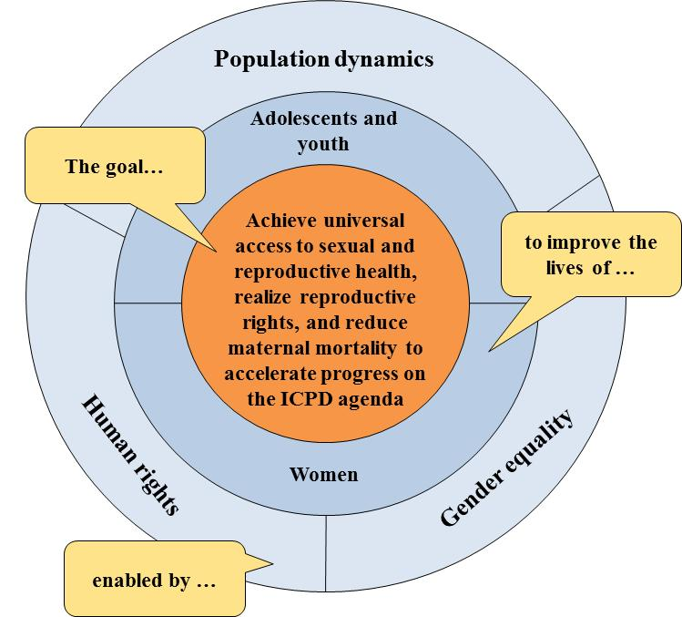

- The bull’s eye is the goal of UNFPA: the achievement of universal access to sexual and reproductive health, the realization of reproductive rights, and the reduction in maternal mortality. The work of the organization is centred on attaining this goal, particularly through an enhanced focus on family planning, maternal health, and HIV/AIDS. Reaching this goal would bring enormous benefits to people across the world by accelerating progress on the ICPD agenda, and would make a major contribution to the MDGs. MDG 5a and 5b on maternal mortality and reproductive health are the central focus of the Fund’s work, but it is important to recognize that improving maternal health has a number of broader developmental impacts for the other MDGs, for example:

- MDG 1 (poverty)
Reducing the complications of pregnancy and childbirth – with the associated costs – and the significant economic benefits of family planning both contribute to poverty reduction.
- MDG 2 (primary education)
Reducing orphanhood by ensuring that fewer women die in childbirth and supporting greater control over family size both facilitate primary education, particularly for girls.
- MDG 3 (gender equality)
In addition to the benefits of girls’ education, achieving universal access to SRH and realizing reproductive rights are fundamental to the attainment of full gender equality.
- MDG 4 (child mortality)
The health of infants is directly linked to the health of their mothers, so reducing maternal mortality and the complications of childbirth will have important benefits in reducing child mortality.
- MDG 6 (HIV/AIDS and other diseases)
Addressing HIV and its effects has been mainstreamed across all aspects of the Fund’s work.
- MDG 7 (environmental sustainability)
Ensuring universal access to family planning is an important component of a path toward sustainable development.
- MDG 8 (partnership)
Supporting access to commodities for SRH contributes to one element of this goal, while the Fund’s efforts on aid effectiveness contribute to another aspect of it.

- Women, adolescents and youth are the key beneficiaries of UNFPA work. The organization will prioritize the most vulnerable and marginalized, particularly adolescent girls and also indigenous people, ethnic minorities, migrants, sex workers, persons living with HIV, and persons with disabilities. UNFPA will work to improve their health and their ability to participate in the decision-making process on the issues that affect their lives, whether those decisions are made at the individual, familial, community, or national levels.

- The outer ring of the bull’s eye contains the key factors that enable the attainment of the goal. Respect for human rights is a principle that underpins all of the Fund’s work. A human rights-based approach can be seen in how UNFPA operates, such as in the emphasis on ensuring that family planning services are free of coercion or that HIV/AIDS interventions are stigma-free.

- The promotion of gender equality is another central principle of the Fund’s work. It is both a key programmatic area for UNFPA – there is an outcome dedicated specifically to it – and a cross-cutting approach that influences all interventions. For example, the focus on gender equality manifests in an emphasis on ensuring that SRH services are provided in a gender-responsive manner, and in promoting the collection and use of disaggregated data to enable identification of the specific needs of women and girls.

- The third element of the outer ring – population dynamics – is an important area of work for UNFPA. The support provided to the preparation and analysis of censuses and other population-based surveys is a critical means of ensuring that women, adolescents, and youth are at the centre of sustainable development policies, and that programmes have the evidence needed to improve SRH services. Helping national stakeholders understand and plan for the implications of emerging population issues such as migration, urbanization and ageing for the SRH needs of women, adolescents and youth is a key area for UNFPA.

- A complete results chain has been developed to show the outcomes and outputs necessary to achieve the goal of the bull’s eye. UNFPA will concentrate on achieving four outcomes, which will be the result of work across 15 outputs. The full set of impact, outcome, and output indicators is contained in the integrated results framework (IRF) included in annex 1.

Outcome 1: Increased availability and use of integrated sexual and reproductive health services (including family planning, maternal health and HIV) that are gender-responsive and meet human rights standards for quality of care and equity in access

- The foundation of the work of UNFPA on SRH is the ICPD Programme of Action, wherein Members States and organizations agreed that all couples and individuals have the right to decide freely and responsibly the number, spacing and timing of their children, and to have the information and means to do so, and that decisions concerning reproduction should be made free from discrimination, coercion, and violence. Outcome 1 operationalizes this through five outputs.

- The first output focuses on two key elements that cut across the remaining outputs: the integration of SRH services and emphasis on ensuring that services are gender-responsive and meet human rights standards. Both elements reflect key challenges facing health systems in many countries around the world: too often SRH services are not fully integrated, such that women with HIV are not offered contraceptive choices, or women attending antenatal services are not given the option of an HIV test. Similarly, too often women – particularly the most vulnerable and marginalized – are confronted with coercive or discriminatory practices, particularly in the context of family planning and HIV services. Responses grounded in a human rights-based approach – particularly ones that are gender-responsive – are essential to addressing these practices.

- At the country level, UNFPA addresses these challenges primarily through advocacy, policy dialogue/advice, and capacity development, such as by supporting national governments to develop guidelines, protocols, standards, and quality of care mechanisms. All of this work is in the broader context of strengthening national health systems with a view to achieving universal health coverage, and is undertaken jointly with a range of national and international partners. UNFPA will increase its focus on ensuring that the particular SRH needs of adolescents and youth are addressed.

- The next three outputs represent the three major pillars of the work on SRH: family planning, maternal health, and HIV. In each of the three outputs, UNFPA will be active across the full range of interventions needed to ensure quality of care: increasing supply of services, generating demand, and improving the enabling environment. The relative balance between these three areas will vary depending on local circumstances, as will the programme strategies. In many countries, the emphasis will be on upstream advocacy and policy dialogue to shift national laws and policies, such as efforts to ensure that countries use the results of an emergency obstetric and newborn care needs assessment to develop a costed national action plan to scale up maternal and newborn health services. Less frequently, UNFPA will be directly involved in service delivery, such as the procurement of commodities, which the organization will continue to do, although this will be paired with capacity development so that countries can assume direct responsibility for it.

- The final output focuses on a particularly challenging situation: the delivery of SRH services in humanitarian settings. A key focus will be on the preparedness of countries to deliver SRH services in crises, including by building capacity to provide the Minimum Initial Service Package for reproductive health and by assisting countries to develop and regularly update contingency plans that address the specific needs in crises of women, adolescents, and youth, including the survivors of sexual violence.

Outcome 2: Increased priority on adolescents, especially on very young adolescent girls, in national development policies and programmes, particularly increased availability of comprehensive sexuality education and sexual and reproductive health services

- A safe, healthy and successful transition from adolescence to adulthood is the right of every child. Yet too often, the second decade of life is fraught with abuses and challenges that impede adolescents’ rights to be educated, healthy, skilled, and empowered as full and active citizens. Sexual and reproductive health is a cornerstone of this transition, shaping the trajectory of young people’s lives for years to come. Outcome 2 addresses these needs of adolescents, particularly very young girls, through three outputs.

- The first output covers the work of UNFPA in convening partners on adolescent and youth issues and in strengthening the capacity of institutions to conduct data analysis related to adolescents and youth so that their specific SRH needs can be incorporated into national laws, policies, and programmes.

- The second output focuses on comprehensive sexuality education. UNFPA works on ensuring that curricula meet international standards and on training educators who deliver comprehensive sexuality education that promotes respect for gender equality and the rights of adolescents and youth to have control over and decide freely and responsibly on matters related to their sexuality. These are areas on which UNFPA collaborates closely with partners such as UNESCO and UNICEF.

- The final output addresses the innovative adolescent girls initiative that UNFPA is launching on child marriage to reach at-risk girls in 12 countries with programming that attempts to work holistically to improve the health, social and economic status of these girls.

- These outputs closely complement the outputs under outcome 1, which address the provision of SRH services to all populations, including adolescents.

Outcome 3: Advanced gender equality, women’s and girls’ empowerment, and reproductive rights, including for the most vulnerable and marginalized women, adolescents and youth

- Reproductive rights are comprised of a constellation of civil, political, economic, social and cultural rights protecting the freedom of individuals and couples to make autonomous, informed decisions about sexuality and reproduction and to enjoy their sexual and reproductive health, free from discrimination, coercion and violence. A multi-pronged approach, including the engagement of local communities, national governments, and international organizations is necessary to address the barriers that impede progress towards gender equality and women’s empowerment. Collaboration with UN-Women is particularly critical in this area.

- As reflected in the outputs, UNFPA focuses on three elements. The first output pertains to the systems that monitor compliance with human rights obligations and recommendations. The work in this area is primarily advocacy and policy dialogue/advice and capacity development to both promote the establishment and use of these systems, and to assist national authorities to monitor violations of reproductive rights.

- The second major area of emphasis is gender-based violence and harmful practices such as female genital mutilation/cutting (FGM/C). A particular focus will be the integration of gender-based violence (GBV) programming into broader SRH services, including in the context of humanitarian programming. Work on FGM/C is through a joint programme with UNICEF, which aims at using a human rights-based approach to engage communities to act collectively to renounce the practice.

- The final output stems from the central role that civil society and faith-based organizations play in promoting reproductive rights and gender equality. UNFPA will support civil society so that it can promote accountability on these issues, and also ensure that men and boys are engaged for the promotion of gender equality and to address their unique SRH needs.

Outcome 4: Strengthened national policies and international development agendas through integration of evidence-based analysis on population dynamics and their links to sustainable development, sexual and reproductive health and reproductive rights, HIV and gender equality

- The final outcome covers the promotion of evidence-based national policies and international development agendas. A key element of this relates to the work of the organization on population dynamics, including the growth or decline of a population from high or low fertility, shifts in age structures, urbanization, and migration. These influence, and are influenced by, many development objectives, including poverty reduction, employment, the status and roles of women in society, inequality, food, water and energy security, and sustainable development, environmental impacts and climate change.

- The outputs of this outcome represent the different phases of the national programming cycle that goes from data, to evidence, to policy and programme design and implementation, to monitoring and evaluation and back to data.

- The strategies that UNFPA uses across these outputs are heavily focused on advocacy and policy dialogue/advice, and knowledge management, supported by some capacity development. Examples include efforts to encourage the inclusion of questions related to SRH and the specific needs of adolescents and youth in household surveys, the development of tools to analyse census data, support to the analysis of key population trends, and training of staff in national statistical offices.

- One area of particular emphasis for the strategic plan is the preparation of the post-2015 development agenda. UNFPA will work at country, regional, and global levels to ensure that it is robustly evidence-based and informed by a thorough understanding of population dynamics, and also to support the inclusion of SRH, reproductive rights, gender equality, the needs of adolescents and youth, and population dynamics in the next development framework.

- Another focus will be on data in humanitarian settings, to use the Fund’s comparative advantage in data analysis to ensure that planning is being done based on up-to-date, disaggregated data that enables vulnerable areas and populations to be identified in advance of crises.

Delivering on the strategic direction

- The preparation of the strategic plan has been used as an opportunity to undertake a comprehensive review of the Fund’s work, which enables the introduction of a series of mutually reinforcing changes that bring coherence to the efforts to strengthen UNFPA.

- The starting point for this is the bull’s eye. The organization must have a robust system that translates this vision into the concrete results it seeks to achieve, and enables them to be measured and so ensure accountability. The Fund’s business model must adapt so that UNFPA is best positioned to achieve these results in a changing world. Shifting the business model alone is not enough, as the Fund’s resources also have to be directed to the same strategic priorities. The synergistic nature of the relationships between the three elements is shown in figure 2.

Figure 2: Conceptual relationship between key elements of the strategic plan
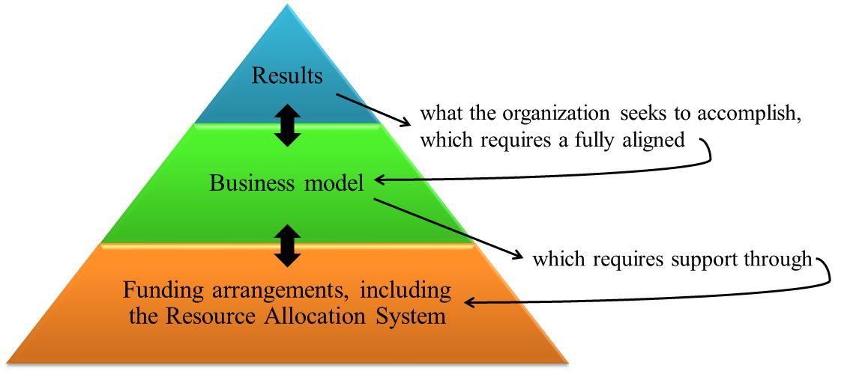

Results

- A number of changes to the Fund’s approach to results measurement are being made to strengthen accountability and better capture the contribution UNFPA makes to improving the lives of women, adolescents, and youth, including the introduction of a new conceptual framework: while historically the organization has separated development and management results into two frameworks, there will now be a single integrated results framework that includes results related to both development and organizational effectiveness and efficiency, as shown in figure 3.

Figure 3: Structure of the integrated results framework
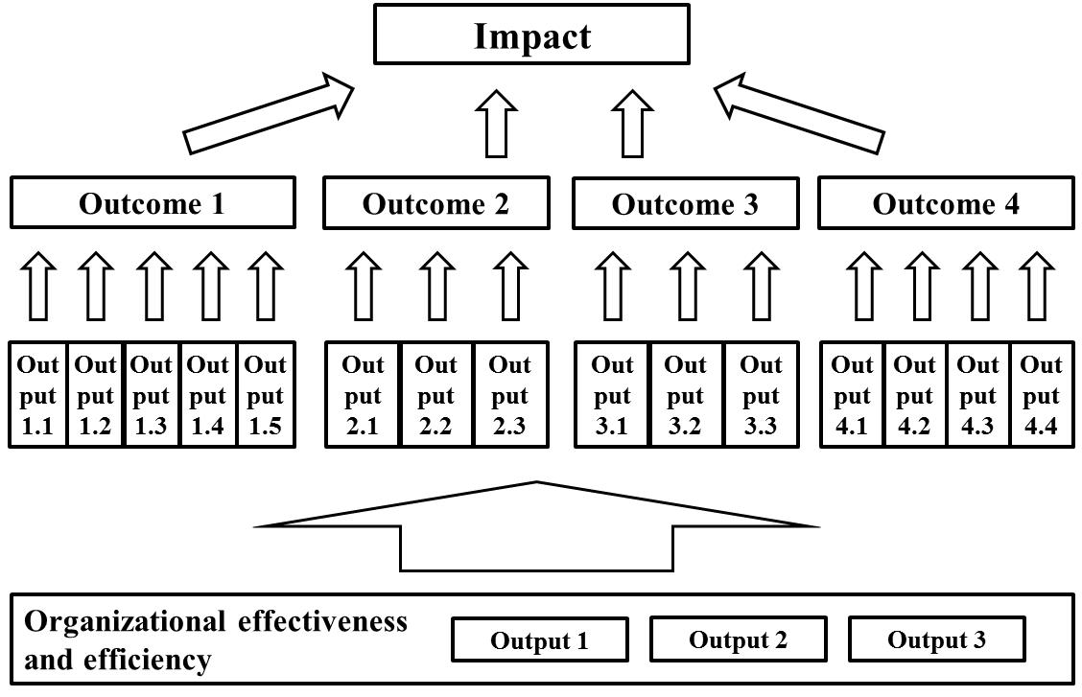

- The structure of the IRF is based on the guidance from the QCPR, including in the incorporation of the three levels of results called for therein: impact, outcome, and output. UNFPA has accountability for results across all these levels, although attribution varies considerably between the impact level – which requires the collective action of many stakeholders – and the output level, where the direct control of UNFPA is strongest. Although the outputs are formulated as changes in national capacity (reflecting the importance of capacity development in the QCPR), the changes captured at this level are a direct result of the work of UNFPA. Theories of change for each outcome show the contributions that UNFPA is making (see annex 2).

- The results framework has been developed in close collaboration with the other funds and programmes, particularly UNDP, UNICEF, UN-Women and WFP. The organizations are all acting in accordance with the United Nations Development Group (UNDG) programming principles, based on the human rights-based approach to cooperation, gender equality, environmental sustainability, results-based management and capacity development, and the terms in the IRF are being used in accordance with the UNDG Results-Based Management Handbook. The agencies also commit to sharing results to the maximum extent possible in thematic areas in which multiple agencies are active.

- The organizations have taken steps towards converging strategic planning, particularly with respect to results frameworks, through actions that include:
- Using performance indicators of the System-Wide Action Plan on Gender Equality and Women's Empowerment to help monitor progress in gender mainstreaming, recognizing gender mainstreaming as essential to achieving results, and the responsibility to promote gender equality through actions in pursuit of the agencies’ mandates;
- Using performance indicators of the UNAIDS Unified Budget, Results and Accountability Framework to help monitor progress in addressing HIV and AIDS and maximize the coherence, coordination and impact of the broader United Nations response to HIV and AIDS;
- Using performance indicators aligned with the approach agreed through ongoing Inter-Agency Standing Committee work on a common Humanitarian Response Monitoring Framework, as part of the newly developed Humanitarian Programme Cycle;
- Harmonizing application of the principles of value for money, based on the concepts of economy, efficiency and effectiveness, including common areas of measurement and reporting;
- Strengthening real-time monitoring systems of government and partners, with particular focus on barriers and bottlenecks faced by the most disadvantaged;
- Selecting a set of common indicators for tracking implementation of the QCPR, based on their relevance, feasibility and cost of collection, and balance across different issues addressed.

- This inter-agency process has improved the quality of the results framework and, more importantly, will facilitate working as a single United Nations at country level, thereby ensuring that the system collectively does a better job serving its beneficiaries.

- For the first time, the results framework contains a significant number of indicators that capture upstream work, to ensure that the Fund’s efforts on advocacy and policy dialogue/advice are adequately reflected. The IRF also now includes the results of UNFPA activities not only at country level but also globally and regionally. The global and regional work of the organization delivers results through two distinct pathways – via support to country programmes and through advocacy, policy dialogue, and knowledge management at the global and regional levels – and the IRF covers both of these. The first pathway is addressed through the indicators of national-level progress, and the second has been included in more detail in the IRF than in the previous results framework. Additionally, an indicator on the quality of support from regional offices has been included.

Business model

- The second major element of delivering on the strategic direction relates to the where, how, and who of the Fund’s work. Figure 4 provides a schematic depiction of these parts of the Fund’s current business model.

Figure 4: High level summary of the current business model
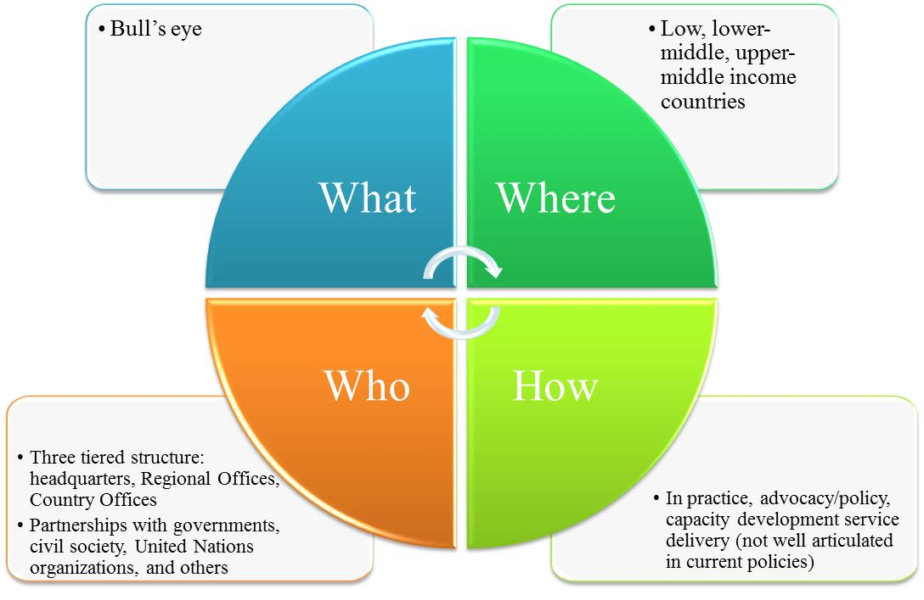

- There are a number of reasons to re-examine the business model, as described in annex 3. To address the issues, a number of changes are being introduced. The foundation for many of these will be establishing greater clarity on the programming strategies that UNFPA should use in different settings, as set out in table 1.

Table 1: Modes of engagement by setting
 | Need
Ability to finance | Highest | High | Medium | Low
Low | A/P, KM, CD, SD | A/P, KM, CD, SD | A/P, KM, CD | A/P, KM
Lower-middle | A/P, KM, CD, SD | A/P, KM, CD | A/P, KM | A/P
Upper-middle | A/P, KM, CD | A/P, KM | A/P | A/P*
High | A/P* | A/P* | A/P* | A/P*
A/P = Advocacy and policy dialogue/advice CD = Capacity development
KM = Knowledge management SD = Service delivery
* Physical presence only in select countries.

- Table 1 is at the heart of the new business model, as it provides guidance for how UNFPA should engage in different country contexts. For example, in countries that have the highest needs and low ability to finance their own interventions (coloured red in the matrix above), UNFPA should be prepared to offer a full package of interventions, from advocacy and policy dialogue/advice through knowledge management and capacity development to service delivery. However, in countries with low need and high ability to finance their own programmes (coloured pink in the matrix above), UNFPA should focus on advocacy and policy dialogue/advice. Further details on how countries are classified are contained in section IV.

- The approach builds on a number of key concepts that were introduced in the MTR, such as not trying to do everything everywhere and addressing better the changing needs of the Fund’s clients. It also responds to the calls in a number of settings – including the QCPR – for the entire United Nations system to shift away from “delivering things” to “delivering thinking”, or move more upstream to focus on advocacy and policy dialogue/advice rather than service delivery.

- One particular area of upstream work in which UNFPA plans increased involvement is South-South and triangular cooperation. The evolving global landscape creates new opportunities to assist programme countries by linking them with other programme countries that have relevant lessons learned to share. UNFPA has an important role to play in helping match countries that have experiences to offer in advancing the ICPD agenda with those that could benefit from support. In line with the Framework of operational guidelines on United Nations support to South-South and triangular cooperation (SSC/17/3), the primary role of UNFPA will be as a knowledge broker that can bridge knowledge gaps by linking demand and supply of expertise, experience, and technology.

- The matrix in table 1 is intended to be used as a starting point for thinking critically about how UNFPA should engage in different settings rather than as a straitjacket. It cannot replace country-level dialogue about national priorities and needs. Thus, UNFPA will preserve the flexibility to respond to the diverse challenges encountered. For example, if a country office in the yellow band (which would normally be focusing on advocacy and policy dialogue/advice and knowledge management) in collaboration with national partners determines that the most effective way to achieve impact given the resources at its disposal would be via capacity development, then it simply needs to provide a justification in the form of a robust business case.

- For the new business model to bring the expected benefits, the deployment of the Fund’s resources – both human and financial – must be aligned with it. For example, countries in the red quadrant are frequently the most managerially complex environments. This will require a larger number of staff, including leaders who have proven track records of managing complicated programmes in challenging settings. Conversely, in countries in the pink quadrant, the work will focus on upstream engagement, which typically requires fewer staff but which necessitates a particular profile of staff who are able to advance the ICPD agenda through partnerships, negotiations, communications, and other skills associated with advocacy and policy advice/dialogue.

- This transformation will not take place in a single “big bang”; rather, the readjustment to the business model will be phased in over the first two years of the strategic plan, with new country programmes expected to reflect these programming strategies from the outset and existing country programmes gradually realigned. This approach will enable UNFPA to maintain a broad country presence despite the organization’s limited budget. The shifts in the business model will not alter this, and it is not envisaged that country presence will change considerably. The alignment of financial resources is also critical, as discussed later in section IV.

- Three other elements of the business model will be the focus of significant changes: regionalization, partnerships, and humanitarian programming.

- A review of the regionalization process has concluded that the establishment of regional offices has not yet delivered on its full potential. One of the most critical steps is to clarify the purpose and expected benefits of regionalization, particularly by revisiting the roles and responsibilities of the regional offices and clarifying the division of labour with headquarters. Broadly, country offices will be responsible for implementing programmes, regional offices for providing support and quality assurance to country offices and engaging with regional entities, and headquarters for providing normative guidance (including the development of tools, guidelines, and standards), providing quality assurance in critical areas (such as around regionalization), and engaging in global advocacy and intergovernmental policy dialogue.

- The nature of support requested of UNFPA from countries has shifted, with many now looking to UNFPA to bring in cutting-edge expertise to engage in high-level technical debates. This requires UNFPA to shift from direct provision of support to playing a brokering role by building relationships at regional levels with academic institutions and civil society partners, and by engaging in South-South and triangular cooperation. While UNFPA has had notable successes in collaborations with regional entities, much of the work with them has been ad hoc, so engaging more strategically with regional bodies will be a priority. Regional offices will also play stronger roles in providing quality assurance and in human resources management.

- On partnerships, the organization needs to create a broader constituency for the ICPD agenda by letting go of it, and instead helping others internalize the relevant aspects of the ICPD agenda and embrace them fully.

- A key element of this at both regional and country levels is the introduction of partnership plans that delineate how UNFPA engages with key partners, such as governments, civil society organizations, and other United Nations organizations. This will include partnerships with emerging actors, such as new geopolitical groups and the private sector. Several initiatives have begun with the private sector and are showing promise, for example, the collaboration with Intel on midwifery education. UNFPA will expand what works and strengthen the culture of engagement with the private sector, so that it is looked to as a source of new ideas and approaches that can advance the ICPD agenda rather than simply a source of financing.

- UNFPA is an active supporter of Delivering as One, and will expand joint programming efforts. Another key element of partnerships is collaboration with implementing partners. UNFPA has made strides in reducing the fragmentation that has characterized its work with implementing partners, which will be continued in a way that is consistent with a broader emphasis on building national capacity rather than substituting for it. This means that the organization will re-emphasize national execution as its preferred modality.

- Within the broader context of continuing to mainstream humanitarian programming across the organization, a number of concrete changes will be made on humanitarian programming, as detailed in annex 3. For example, in line with the focus on preparedness in the Inter-Agency Standing Committee’s transformative agenda and the QCPR, UNFPA will work with national authorities in select high-risk countries to ensure that the SRH needs of women, adolescents and youth are adequately addressed in preparedness and contingency plans. This effort will provide a key support to disaster risk reduction, as called for in the Rio+20 outcome document. Together, these initiatives will strengthen the Fund’s humanitarian programming and thereby its contribution to the human security agenda.

Funding arrangements

- UNFPA has historically received the majority of its financing from regular resources, although the share of other (non-core) resources has increased in recent years. If the experience of other United Nations agencies is any guide, this shift is likely to continue, so it is important that the organization analyse the consequences and be prepared for them.

- There are several different mechanisms that determine the use of resources, and each mechanism currently has a separate governance structure, a separate set of allocation criteria, a separate process owner internally, and a separate process for budget preparations and monitoring.

- This fragmentation has a number of detrimental consequences, so UNFPA will move progressively to a more unified funding architecture. This is straightforward in principle, but there are a number of operational and governance complexities that need to be addressed so that existing programmes are not disrupted. There are some steps that can be taken in the short-term to improve the situation, but any more fundamental changes would only be phased in over the course of 2014-2017.

- In terms of immediate steps, the resource allocation system (RAS) will be updated to ensure that it is firmly based on the strategic priorities, as discussed in section IV. The global and regional interventions will be integrated fully into the strategic plan and the integrated budget, as described in annex 4. Finally, criteria that allow for consistent allocation of resources across the funding channels will be introduced.

Organizational effectiveness and efficiency

- For this comprehensive approach to reform to succeed, UNFPA will have to continue to strengthen its internal management and operations. The organizational effectiveness and efficiency (OEE) section of the IRF contains the foundational elements of the management and development effectiveness work of UNFPA that enable the attainment of development results. A set of three outputs has been developed, as follows:
- Enhanced programme effectiveness by improving quality assurance, monitoring, and evaluation;
- Improved mobilization, management, and alignment of resources through an increased focus on value for money and systematic risk management;
- Increased adaptability through innovation, partnership, and communications.

- Significant efforts have been made in recent years to strengthen the quality of the Fund’s programming, such as by introducing quality assurance mechanisms. UNFPA will continue to focus on ensuring that country programmes are of a high quality and will ensure that programme monitoring is elevated as a priority, such as through a collaboration with UNDP and UNICEF to strengthen real-time monitoring. Evaluation will be an important area of focus for the coming period, with the establishment of an independent Evaluation Office.

- Other organizational priorities discussed above – such as preparedness planning for humanitarian crises and regional support to country offices – will also be tracked under this output. A final dimension of the output is transparency, which is linked to commitment that UNFPA has made as a signatory to the International Aid Transparency Initiative as part of a broader push around improving aid effectiveness.

- The second output places particular emphasis on ensuring value for money in UNFPA operations and on systematizing approaches to risk management. Risk management is increasingly important in a complex world, and UNFPA is still in the early stages of establishing the systems and culture that will enable the organization to appropriately handle risks of all types – contextual, programmatic, or institutional.

- One key element of risk management is the diversification of the funding base: UNFPA has experienced considerable growth, but remains heavily dependent on a limited pool of donors, and must therefore redouble efforts to generate resources from new sources. As a reflection of the priority accorded to this issue, additional human resources are being added at the regional level to build new partnerships and generate additional resources from non-traditional sources.

- Improving human resources management is another key focus. The performance of the organization continues to be impacted negatively by vacancies in key positions, so the emphasis will be on to efforts that can address this. For example, specialized human resource staff will be placed in regional offices for the first time, and key country offices (e.g., those in the red quadrant) will benefit from additional operations staff.

- With regard to financial management, considerable progress has been achieved over the past several years, such as improving audit performance and reducing overdue fund accounts. The organization has managed to contain management costs, and this has been a guiding principle for the preparation of the integrated budget. At the country-office level, focus will remain on ensuring robust selection and oversight of implementing partners.

- The last element of the second output is the alignment of resources. The strategic plan sets out an ambitious agenda to improve UNFPA, and this can only succeed if the human and financial resources of the organizations are put behind the changes, so the progress in implementing the business model will be tracked carefully.

- The final output is derived from the recognition that UNFPA must become more adaptable, flexible, and nimble if it wishes to have an impact in a world that is increasingly complex and fast-moving. To date, flexibility in the use of resources has not been a hallmark of the organization, so this will be strengthened. One key element of this is innovation. Although there are numerous examples of innovative approaches to programming throughout the organization, there is not a strong culture of experimenting with new ideas, failing, learning lessons, and trying again.

- To address this, a number of specific areas are being explored. For example, the organization is working on improving supply chain management through technological innovations such as radio-frequency identification tagging, and taking advantage of the opportunities presented by “big data” to generate information for decision-making rapidly (including in humanitarian settings), which UNFPA is exploring through a partnership with a leading private sector firm. To help create a culture of innovation an “Opportunities Fund” will be established, as described in section IV.

- The two other key elements of this output are partnerships and communications. Both of these are at the heart of how UNFPA advances the ICPD agenda. Both are also areas in which the organization can improve, such as by helping partner organizations to fully own the ICPD agenda, as described above. An emphasis will also be placed on ensuring clear division of responsibilities with other United Nations organizations. Strengthened collaboration at the global level will contribute to this, but the primary emphasis will be on ensuring clarity at country level.

- Taken together, these three outputs will enable UNFPA to become more effective and more efficient, and thereby have a greater impact on the lives of women, adolescents, and youth. Additionally, they will allow the organization to track the implementation of the QCPR, as a number of indicators have been designated for monitoring progress on this, including a set of 10 that are from the UNDG QCPR action plan and are shared with other funds and programmes.

Resources and results

Resource needs and flows

- The work of UNFPA occurs within the broader context of global efforts on the ICPD agenda. Resources for these have been increasing in recent years, reaching $11.6 billion in 2011 and projected to grow to $12.3 billion in 2013. This is largely a result of increased financing for HIV/AIDS and sexually transmitted infections, which now accounts for more than 60 per cent of the total, although following the London Summit on Family Planning in 2012 the resources for family planning are expected to increase.

- Estimating domestic expenditures on the ICPD agenda is challenging and subject to activities in a given year. The trend appears positive, with expenditure reaching $54.7 billion in 2011. The majority of this is out-of-pocket expenditure by consumers, especially in Asia. This is also expected to increase in the years ahead, reaching $58.9 billion in 2013. This growth has contributed to narrowing significantly the resource gap for the ICPD agenda.

Linking resources and results

- Based on historical trends, the information provided by donors, and scenario modelling, UNFPA forecasts that a total of $4.56 billion will be available to it from 2014-2017. The overall picture is encouraging, but this increase is coming primarily from rising non-core contributions, which represents a considerable shift from the historical funding pattern, where a majority of resources were regular. This change has important implications for the management of both human and financial resources.

- Table 2 presents the development results outcomes and the OEE outputs from the IRF, and the projected resources to be spent on each, broken down by cost classification and harmonized functional cluster.

Table 2: Integrated results and resources framework 2014-2017 (indicative) (in millions of dollars)
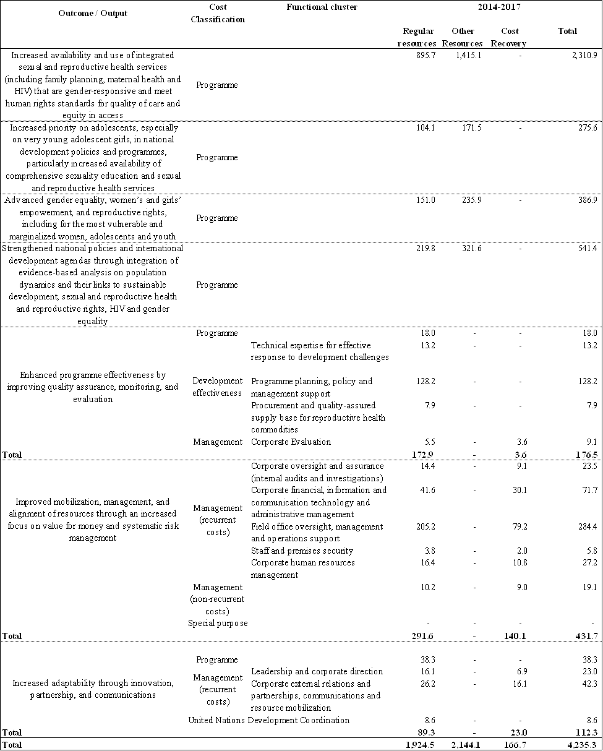

- As can be seen in the table, the most significant area of investment is SRH, in line with the focus of the bull’s eye. The integrated budget discusses the priority investments in more detail.

The allocation of programmatic resources

- A key element of the strategic plan is a revision of the mechanisms that allocate programme resources to country, regional and global levels.

- As described in annex 4, a number of problems have been identified with the current RAS. The changes to the system will ensure that it is more closely tied to the bull’s eye, is more focused on need, and takes into account the programme strategies used.

- The revised RAS will use a streamlined set of six indicators, all of which now relate directly to the work that the organization does:
- Proportion of births attended by skilled health personnel for the poorest quintile of the population;
- Maternal mortality ratio;
- Adolescent birth rate;
- Proportion of demand for modern contraception satisfied;
- HIV prevalence among population aged 15-24 years;
- Gender Inequality Index.

- Two additional areas will be included as supplemental factors rather than indicators: risk for humanitarian crises and income inequality.

- To combine these indicators, a simple, points-based system that assigns weights (points) first to each indicator (inter-indicator weighting) and then to levels of need within an indicator (intra-indicator weighting). The inter-indicator weightings are shown in figure 5.

Figure 5: Inter-indicator weightings
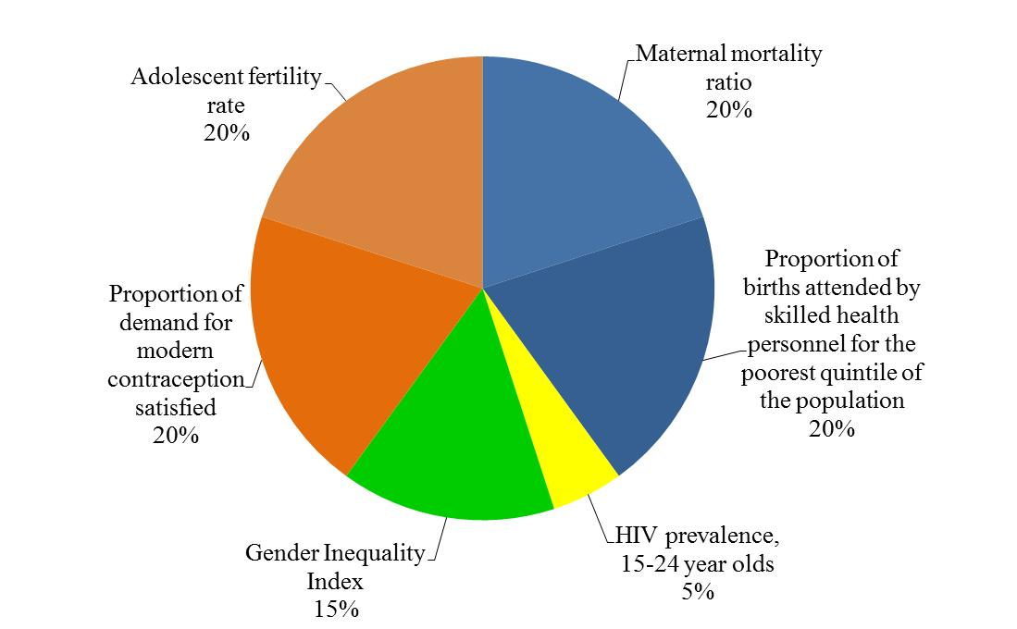

- The intra-indicator weighting is tied to the business model, particularly the recognition that the Fund’s modes of engagement will vary by setting. These different modes of engagement determine the amount of points assigned: because UNFPA must be prepared to deliver a full package of services in the highest need countries, countries in this quadrant are assigned the maximum number of points for a particular indicator. In low need settings, UNFPA generally focuses only on advocacy and policy advice/dialogue, so the number of points assigned to the country is reduced.

- The resulting calculation of points is used to group countries into the red, orange, yellow, and pink quadrants shown earlier in the discussion of the business model. Annex 4 contains a list of countries by quadrant. Indicative figures for each country are calculated based on the combination of need, ability to finance its own programming, and the population (as measured by total female population aged 10-24). In addition to this, a minimum amount of money is set aside for programming in all countries (except for a few countries in which exceptional circumstances mean that different amounts will be allocated). These resources constitute a “floor” that provides a foundation to enable country offices to carry out advocacy and policy dialogue/advice, and to engage on issues related to population dynamics. The floor is set at $500,000 per annum per country classified as low or lower-middle income by the World Bank, and $300,000 per annum per country classified as upper-middle or high income.

- In addition, if countries that are classified as upper-middle or high income make contributions to their own country programme, UNFPA will match these on a one-to-one basis up to a further $100,000 (on top of the $300,000 floor). Therefore, if a country classified as upper-middle or high income provides a contribution from its domestic resources of $100,000, the total resources for the floor would be $500,000 (the initial $300,000, the contribution from the country of $100,000, and the matching UNFPA contribution of $100,000).

- Importantly, the ultimate decision about the level of resources a country will receive is not determined by the RAS: instead, these figures are approved individually by the Executive Board in the country programme documents (CPDs). The planning figures for CPDs are developed based on a flexible resource distribution system that takes into account local needs and priorities, including as manifested in United Nations Development Assistance Frameworks.

- The RAS does set ranges for each grouping of countries, as shown in table 3. As noted in this table, different ranges would be set for 2014-2015 and 2016-2017, to reflect the fact that the new RAS will be phased in progressively: the transition will begin in 2015 for the small number of countries that have new CPDs beginning that year, while for the majority of countries, the transition will only occur in 2016 to ensure that countries have adequate time to adjust.

Table 3: Distribution of resources, population, and countries by quadrant
 | Share, 2014-2015 | Share, 2016-2017 | Share of population | Number of countries
Red | 50-52% | 59-63% | 18% | 40
Orange | 21-23% | 20-22% | 30% | 21
Yellow | 10-12% | 6-8% | 9% | 16
Pink | 15-17% | 9-13% | 44% | 44

- The above-mentioned changes address most of the challenges with the current RAS, but several additional elements are important to cover the remaining issues. The RAS does not incorporate a mechanism to optimize resources across the entire portfolio, such as by rewarding good performance. This has not been included because UNFPA must first develop an objective way to assess the performance of country offices and thereafter a mechanism to reward good performance can be incorporated into the allocation of resources.

- Secondly, the current system must be strengthened to facilitate rapid responses to humanitarian crises. Therefore, the Emergency Fund will be increased from $3 million to $5 million. This Fund is not intended to become the primary vehicle to finance the humanitarian response, but it nonetheless plays an important role in providing catalytic funding, which often serves to increase capacity to generate additional resources.

- The final additional area is the creation of an Opportunities Fund. This will be a new instrument with two distinct but interrelated purposes: as a funding mechanism and as a way to strengthen the culture of innovation throughout UNFPA. More information is contained in annex 4.

- Changes will also be introduced in the process for allocating resources for global and regional programming, as discussed in annex 4.

- The new approach to resource allocation will improve the overall effectiveness and efficiency of UNFPA, enabling the organization to have a more significant impact on the lives of women, adolescents, and youth.

Operationalizing the strategic plan

Aligning global, regional and country levels

- The strategic plan provides a framework for UNFPA programming. The particular interventions that UNFPA supports will always be determined by local needs and conditions, within the parameters of the IRF and the business model. The organization prides itself on being responsive to the needs of the countries in which it works, in line with commitments from the Paris Declaration, the Accra Agenda for Action, and the Busan Partnership for Effective Development Cooperation. The realignment of CPDs to the new strategic plan will occur progressively, with the transition expected to be completed by the end of 2015.

- The overarching principle of being focused that was highlighted in the MTR will remain important. For example, country offices are expected to concentrate on the IRF outcomes and outputs that are relevant for their local contexts, rather than trying to do everything everywhere.

- To ensure that these changes are adopted in a coherent manner, each office across the organization will prepare a plan that describes the steps that it is taking to align itself with the strategic direction. These plans will be monitored closely by UNFPA management to ensure that alignment is occurring as anticipated.

Monitoring, reviewing, and evaluating

- Accountability for the results set out in the strategic plan is of critical importance, so UNFPA will assess performance in three ways. First, as described above, improving monitoring will be a focus across the organization. The indicators included in the IRF will be the starting point for this, and they have been rigorously assessed for measurability. This emphasis on measurability will flow down to country level through the inclusion of new standards on monitoring that will be tracked in the IRF. Annual reports will review progress across the IRF.

- A midterm review will be conducted. This will also provide an opportunity to adjust the strategic plan to take into account the 2014 review of the ICPD, and, to the extent possible, the post-2015 development agenda.

- The revised UNFPA evaluation policy (DP/FPA/2013//5) was approved by the Executive Board at the annual session 2013, and evaluations under the strategic plan – both of the plan itself and of particular programmes – will be governed by this policy. Therefore, the present document does not set out a comprehensive evaluation plan. However, it is clear that the key changes introduced in the strategic plan must be assessed rigorously, and that findings from evaluations must inform the strategic plan for 2018-2021.

________________

The fact that there is not an indicator on population dynamics should not be interpreted as indicating that the organization does not consider this an important area of work. Unlike the other areas in which UNFPA operates, there is no indicator for population dynamics that has a normative directionality that would make it suitable for inclusion. Therefore, the work in population dynamics has been handled differently, with the floor providing resources for work in this area, and the population size of a country factored in separately.
Figures do not add to 100 per cent because of rounding.
11 per cent excluding India.
26 per cent excluding China.

