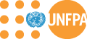

United Nations Population Fund

The UNFPA strategic plan, 2014-2017

Annex 4
Funding arrangements

Summary

This document presents annex 4 (which focuses on funding arrangements) to the UNFPA strategic plan for 2014-2017. This annex concentrates particularly on the architecture through which the organization allocates its resources, the Resource Allocation System, the Global and Regional Programme, and other mechanisms for allocating programmatic resources, particularly the Emergency Fund and the Opportunities Fund.

Contents

Page
I. Introduction 3
II. Architecture 3
III. The financing for interventions at the global and regional levels 4
A. Introduction 4
B. Global and regional interventions 5
C. Allocating resources 7
D. Achieving results 9
E. Roles and responsibilities 10
IV. The resource allocation system 10
A. Background 10
B. Key challenges 12
C. Addressing the challenges 16
V. Other mechanisms for allocating programmatic resources 28
A. Emergency Fund 28
B. Opportunities Fund 28
C. Strengthening mechanisms to optimize resources across the organization 29
VI. Benefits of the new approaches 30
Appendix: Classification of Countries/Territories 31

Introduction

- This annex to the strategic plan, 2014-2017, covers the funding arrangements of UNFPA. In particularly, four key elements are focused on:

- The architecture through which the organization allocates its resources to finance programmatic and management activities;
- The financing for interventions at the global and regional levels (hitherto known as the global and regional programme [GRP]);
- The resource allocation system (RAS), for allocating resources at the country level;
- Other mechanisms for allocating programmatic resources, particularly the Emergency Fund and the Opportunities Fund.

Architecture

- UNFPA receives resources in two ways: regular and other (non-core) resources. The former is the core financing for the organization, while the latter is intended to be used for particular projects or programmes. UNFPA has historically received the majority of its financing from regular resources, although the share of other resources has increased in recent years, reaching 54 per cent in 2012 (up from an average of 43 per cent over the preceding five years). If the experience of other UN agencies such as UNDP and UNICEF is any guide, this trend is likely to continue, so it is important that the organization analyse the consequences and be prepared for them.

- Within the overarching categories of “regular” and “other” resources, there are several different ways in which the resources are used:
- The resource allocation system: regular resources used for programmatic purposes at the country level (which are actually determined in the country programme documents);
- The global and regional programme: regular resources used for programmatic purposes at the global and regional levels;
- The institutional budget (which includes both a regular resources component and other resources component): resources used for management and development effectiveness activities;
- The thematic funds: the funding mechanisms for other resources that are used for specific purposes, such as the Global Programme to Enhance Reproductive Health Commodity Security and the Maternal Health Thematic Fund;
- Other earmarked funds: resources that are generated through other means (such as from the Central Emergency Response Fund for humanitarian interventions or from governments for programming in their own countries) and that are used for specific purposes.

- Traditionally, decision-making about the allocation of UNFPA regular resources has featured separate processes for the institutional budget, the global and regional programmes, and the resource allocation system, although some progress has been made in bringing these together in the development of the integrated budget, 2014-2017. Decisions about the allocation of thematic trust funds and other non-core resources are primarily through numerous different donor agreements, which are not always coordinated with each other or with the allocation of regular resources.

- As a result of the siloed nature of decision-making about resources, each of these mechanisms currently has a separate governance structure, a separate set of allocation criteria, a separate process owner internally, and a separate process for budget preparations and monitoring.

- This fragmentation has a number of consequences. Most importantly, having separate budgeting frameworks for different types of regular and other resources makes it impossible to have a globally coherent allocation of resources to strategic priorities. This impedes the ability of the organization to make optimal use of the total resources, lessening the Fund’s impact. The fragmentation makes it more difficult to track resources against results, thereby reducing accountability. Finally, the current architecture increases the transaction costs for country offices, which are forced to manage and report in siloes.

- The integrated budget, 2014-2017, helps address some of these issues. For example, for the first time budgetary requirements associated with the global and regional programme were gathered at the same time as requirements for the institutional budget, and a concerted effort was made to transfer non-programmatic elements of the global and regional programme into the institutional budget and vice versa. However, the integrated budget cannot address all of the underlying causes of fragmentation. Most importantly, although it can provide extensive details about regular resources, the unpredictable nature of other resources – which generally reflect shorter-term commitments by donors and so are more volatile – means that the integrated budget cannot contain as much information about other resources. Moreover, the governance mechanisms for other resources remain separate from those for regular resources.

- To further address the challenge of fragmentation, UNFPA will move to a more unified funding architecture. Conceptually this is straightforward, but there are a number of very real operational and governance complexities that need to be addressed in a progressive manner so that existing programmes are not disrupted. Some aspects can be addressed in the short-term, such as by introducing more consistent criteria that can be used across the funding channels and by unifying the management of thematic funds.

- Any more fundamental changes, though, would only be phased in over the course of the next strategic plan period of 2014-2017, as it will take time to develop and then implement a more unified system of decision-making that optimizes resources across the institution, irrespective of funding source. Any changes requiring Executive Board approval would be introduced in the midterm review of the strategic plan, and the Executive Board would be engaged regularly in the process of developing them.

The financing for interventions at the global and regional levels

Introduction

- In 2007, the UNFPA Global and Regional Programme (GRP) for the period of 2008-2011 was defined in document DP/FPA/2007/19, approved by the Executive Board at its second regular session in 2007. A performance audit of the GRP covering the 2008-2011 period recently raised a number of issues that had previously been identified by UNFPA management and largely addressed following the midterm review of the current strategic plan. UNFPA has since built upon those reforms in preparing the strategic plan and integrated budget for 2014-2017 and in strengthening the framework for allocating regular resources to global and regional interventions going forward. The results are presented in this section, which both articulates the need for global and regional interventions and describes the specific types of activities that will optimally be funded through UNFPA regular resources over 2014-2017. The section further describes the robust and transparent mechanisms through which UNFPA will effectively manage and govern the resources it allocates to global and regional interventions as well as the oversight mechanisms it has put in place in order to maximize their potential impact. Although thematic trust funds also fund “global and regional interventions”, this paper will not deal with these initiatives, but rather focuses only on global and regional interventions funded by regular resources.

- Since 2009 UNFPA had realized many of the important issues highlighted in the Performance Audit, such as (a) concerns regarding the management and oversight of the GRP; (b) overbudgeting of the GRP in total, but for the 'Global' portion in particular;
(c) improper follow-up to the 2007 'Evaluation of the Intercountry Programme' and the 'Audit Report of Regional Projects at UNFPA'; (d) weaknesses in results-based management; and
(e) areas for improvement in the GRP capacity-building efforts. Several of those issues have since been resolved – some prior to the performance audit – through a variety of initiatives, such as a revised GRP allocation process and criteria since 2011 putting emphasis on enhanced results-based management (RBM) practices and re-establishing GRP key fiscal indicators in the decision-making process, an overhaul of the respective programme policy framework, and enhanced RBM training options for GRP managers..

- The organization will institutionalize and consolidate the GRP reforms launched in 2011 as part of the 2014-2017 strategic plan and integrated budget. More specifically, this means enhancing the clarity on the mechanism for global and regional interventions overall, more robust processes for resource allocation, more transparency, reinforced control and oversight mechanisms, and a system ensuring continued compliance with the established parameters. All this will ensure that the issues that were identified during the 2008-11 GRP will not reoccur in the future. This will also be part of a longer-term implementation of the UNFPA vision of a unified funding architecture, which will realize the full potential of its funding arrangements by 2017.

Global and regional interventions

Purpose of global and regional interventions

- There seems to be a clear need for interventions that complement efforts done through country programmes, both at a global and regional level. Global and regional interventions are crucial for effectively and efficiently delivering on the strategic plan, 2014-2017, because the realization of the International Conference on Population and Development (ICPD) agenda at the country level is fuelled in significant part by global and regional leadership. Also, country programmes are strengthened by the transfer of know-how compiled and disseminated within and across regions. In addition, there are large economies of scope and scale in generating and building support for and knowledge about ICPD issues and solutions; and as obviously, population and development issues that cross national boundaries often benefit from collaboration across borders.

Recent examples

- Global and regional interventions have long played a vital role in the work of UNFPA to advance the ICPD agenda. A number of initiatives funded by the GRP since 2008—including the annual State of World Population report, the Campaign to End Fistula, and Women Deliver conference, for instance—are recognized as having contributed significantly to the knowledge base underpinning global efforts to advance the ICPD agenda. They have likewise helped in heightening awareness, forging consensus, and building the momentum to move ICDP goals forward. Other global work funded by the GRP has helped strengthen UNFPA programming capacity, for example by institutionalizing evidence-based programming, strengthening results-based management, and revamping the organization’s structure around regional offices, in line with the UNFPA field-focused agenda. Regional offices have used GRP funding to build upon country-level interventions through initiatives such as the Campaign on Accelerated Reduction of Maternal, New Born and Child Mortality (CARMMA) in Africa, and the Youth Peer Education Network (Y-PEER) in Eastern Europe and Central Asia, for example.

Scope of global and regional interventions

- UNFPA experience with global and regional interventions demonstrates that the following types of programmatic activities best complement country programmes and help maximize institutional impact along the dimensions outlined above:
- Generation and sharing of knowledge/data;
- Advocacy;
- Intergovernmental policy dialogue;
- State-of-the-art technical knowledge;
- Standards and norms;
- Capacity development;
- Technical, operational and programmatic field support.

- While these are generally the best types of activities to pursue at the global and regional levels to leverage its overall resource endowment to greatest effect, it is important to note that each intervention must be carefully designed and weighed according to the specific needs and outcomes to which it is expected to contribute in the context of the strategic plan.

- It is important to note, however, that some global and regional interventions may be strictly considered by auditors as management or development effectiveness costs. The reality is that in some cases the lines between programmatic and development effectiveness costs are not entirely clear. In the process of developing the Integrated Budget for 2014-2017, UNFPA has closely scrutinized the classification of regular resources across programmatic and non-programmatic categories and substantially shifted costs between them. The result is a budget in which uses of funds are much more closely mapped according to the appropriate programmatic, development effectiveness, or management cost categories. At the same time, there are demands upon the institution that emerge only after the quadrennial budget is developed, as may be mandated by the Executive Board, for instance. When the scope of the UNFPA global or regional responsibilities expands, it is sometimes necessary and appropriate for the institution to rely on additional regular resources for activities that may be considered by a strict interpretation of DP-FPA/2010/1-E/ICEF/2010/AB/L.10 as management or development effectiveness costs. These activities should normally have been funded by the institutional budget, but since the institutional budget lacks the necessary flexibility during the budget cycle, the funding mechanism for global and regional interventions may still need to be used for this purpose. Thus, it should be noted that there are still some perceived imperfections and more efforts are needed for the period to come.

- The procedures outlined below have been established to ensure that all global and regional interventions are approved and closely tracked through systematic and transparent mechanisms. A fully transparent and robust resource allocation process with well-defined eligibility criteria applied to all global and regional interventions, including those that emerge during the 2014-2017 period, will help to ensure that funds devoted to these purposes are not used simply as a supplement to cover core institutional administration costs.

Allocating resources

Principles

- For the period of the strategic plan, 2014-2017, allocations for global and regional interventions will be based on the following principles:
- Compliance with the funding parameters agreed upon with the Executive Board;
- Coherence with and specific contributions to the strategic plan, 2014-2017, outputs/results;
- Transparent decision-making criteria and processes;
- Robust and independent peer review/quality assurance mechanism;
- Well-defined institutional roles and responsibilities.

- It is important to note that all of UNFPA core funding for global and regional interventions over the 2014-2017 period will be allocated through a framework built squarely upon these principles, starting with the initial funding requests that were submitted as part of the Integrated Budget exercise and have been elaborated upon in detailed action plan proposals, which are available online for the information of all UNFPA staff and the Executive Board, as discussed below.

Parameters

- The overall resource ceiling for global and regional interventions is set at $275 million from regular resources based upon past experience and the reapportionment of overhead costs, along with the knowledge of upcoming demands and UNFPA need for flexibility to respond to emerging needs and opportunities in rapidly changing environments. In line with the stipulations of the earlier GRP, 60 per cent of programmatic funds for global and regional interventions will be managed through regional offices, and the remaining 40 per cent will be managed by headquarters business units at the global level. These ratios will be strictly adhered to.

- Initial allocations between regions are based on a weighting factor that takes into account their levels of need based on the types of work that will be undertaken to address those needs as per the business model, including the need for support to countries in the region. Specifically, the weights are as follows:
- Equal baseline amount for all regions (25%);
- “Needs” score from the RAS for the countries of the region (25%);
- Total Country Programme amount (5%);
- Number of countries (20%);
- Number of countries that are in the pink quadrant in the RAS (25%).

- For headquarters units, initial distributions will be made based on historical expenditures and the needs and opportunities to contribute to the outcomes identified in the Integrated Results Framework (IRF), as per the detailed action plans submitted by each unit.

Process

- Allocating resources to global and regional interventions within the parameters defined above is a straightforward process that leverages an existing peer review mechanism managed by the Programme Review Committee (PRC) Secretariat, hosted by the Programme Division (PD), as well as involving the Division for Management Services (DMS), and the PRC itself (which is made up of the members of the Executive Committee (EC) plus three Country Representatives selected based on the quality of the country programme documents), as per the diagram below.
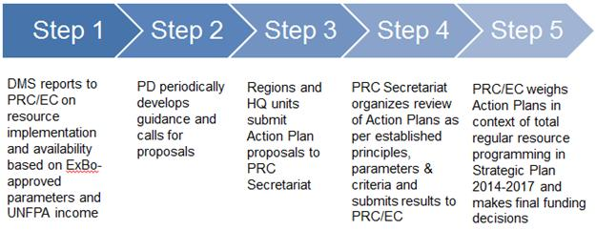

- The peer review mechanism managed by the PRC secretariat is a tested and credible quality assurance mechanism that has helped to significantly elevate the quality of UNFPA country programme documents. A team of two peer reviewers for each action plan is drawn randomly from a roster of volunteers, which all senior UNFPA staff at the regional, sub-regional and headquarters levels have been invited to join. Reviewers assess programmatic and financial aspects of each proposal and their feedback is provided to regional offices and headquarters units for action plan improvement. As outlined in the diagram above, the PRC/EC considers peer reviewer input and recommendations and makes final funding decisions on the proposed action plans.

Criteria

- Action plan proposals must detail:
- The Integrated Results Framework outputs to which activities contribute;
- Output indicators, including baselines and targets;
- A description of activities to be undertaken;
- Implementing partner(s);
- Required resources.

- The criteria that peer reviewers apply when providing feedback on a proposed action plan are as follows:

Review Dimensions | Criteria
Strategic alignment | - Alignment with UNFPA strategic direction  - Human rights-based approaches  - Linkages/contribution to the Integrated Results Framework  - Prioritization and focus on priority outputs
Results-based management | - Clear contributions/Linkages between outputs and outcomes  - Precise and measurable output indicators with baselines and targets
Using evidence and lessons learned | - Justification based on evidence of gaps and needs  - Use of lessons learned from past GRP performance  - Monitoring mechanisms defined
Financial resources/ budget | - Adequacy of resources for results  - Cost reasonableness  - Value for money

- A detailed list of these criteria is available online, along with the forms reviewers use to evaluate each action plan proposal. The focus of UNFPA efforts to improve the management and governance of regular resources destined to global and regional interventions is upon the transparency and consistency with which the above criteria are applied to each and every dollar of funding. The results of the first round of peer reviews for the 2014-2017 global and regional action plans proposals submitted by each regional office and headquarters unit, along with the detailed proposals, are also available online, at the address indicated below.

Achieving results

Monitoring and reporting

- Results-based management requires that performance indicators, baselines, and targets be set at the outset of any intervention, as they form the basis for monitoring and reporting on effectiveness. Output indicators for global and regional interventions are a required component of the global and regional action plans, and are reviewed as part of the peer review process. Similarly, the monitoring arrangements for global and regional results must be identified in the action plan.

- It is important to emphasize that additional changes to the way UNFPA monitors and reports on its effectiveness as an organization will be required, and the GPS is simply one step in that direction. In the context of developing a unified framework for resource planning and budgeting architecture, UNFPA must also develop mechanisms to monitor and report on all of its institutional activities in an integrated way, including both programmatic and non-programmatic functions.

- In the meantime, regional offices and headquarters units will report to the Executive Committee periodically on progress against their approved action plans for global and regional interventions. To the extent possible, these progress reports will be based on the UNFPA existing reporting system. These progress reports will be supplemented by a midterm review of global and regional interventions – as part of the midterm review of the 2014-17 strategic plan. The Division for Management Services will continue to provide the Quarterly UNFPA Positions Statistics Overview as well as the quarterly updates it provides on implementation rates, resource balances, and audit findings and status. These reports cover all of UNFPA resources, including for global and regional interventions. In order to avoid fragmentation, progress on global and regional interventions will be reported on the whole in the UNFPA regular annual report and the annual statistical and financial review.

Evaluation

- UNFPA has recently introduced a new evaluation policy (DP/FPA/2013/5), approved by the Board in June 2013, and is in the process of establishing a separate Evaluations Office that will report directly to the Executive Director. It is anticipated that by elevating the importance of the evaluation function, devoting more resources to it, and enhancing the institution’s capacity to deliver robust assessments of programmatic interventions, UNFPA will make considerable strides in understanding how it can be more effective and efficient in delivering impact. These insights will then be plowed back into future interventions. Global and regional interventions will be evaluated in the context of, and along with, all other programmatic interventions.

- Evaluation findings will then be factored into the review criteria for future global and regional interventions to enhance the quality of the action plans that ultimately receive funding and contribute to greater institutional impact.

Roles and responsibilities

- Roles and responsibilities for the governance and management of global and regional interventions are defined in the following diagram.
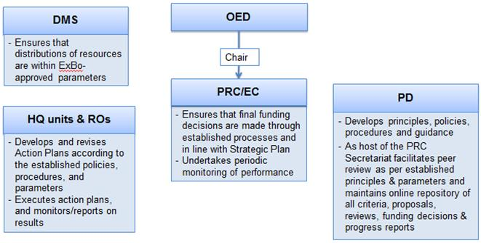

- To provide for transparency and consistency, the following are posted online on an internal dedicated webpage maintained by the PRC secretariat:
- All policies, procedures & timelines;
- All action plan submissions and status;
- Summary recommendations of peer reviewers;
- PRC recommendations and Executive Committee funding decision.

The resource allocation system

Background

- The resource allocation system (RAS) is one of the funding channels discussed above, and so it is affected by some of the broader challenges described above. Additionally, as the share of regular resources declines and other resources increases, it will become increasingly important to manage the programme resources allocated through the RAS in a manner that is harmonized with the programmatic parts of funding coming from other resources.

- However, there are a number of pressing issues associated with the RAS that need to be addressed irrespective of the broader improvements to the funding architecture. To understand the current challenges with the RAS it is necessary to examine the workings of the system carefully.

- The current framework was introduced in 1996, and reviewed and refined by the Executive Board in 2000, 2005 and 2007. The most recent update to the RAS is detailed in DP/FPA/2007/18 and was approved by the Executive Board through decision 2007/42.

- The paper DP/FPA/2007/18 states a set of guiding principles for the RAS:
- “Adherence to the principles of the ICPD Programme of Action;
- “Financial assistance focused on countries with the lowest level of achievement with regard to the ICPD agenda, as reflected in the UNFPA strategic plan goals on population and development, reproductive health and gender;
- “The phasing out or limiting of financial assistance to countries that are close to attaining, or that have already surpassed the ICPD goals;
- “Special attention to low-income countries, the LDCs, sub-Saharan Africa and countries in emergencies, transition and recovery;
- “The promotion of national capacity-building through South-South cooperation;
- “The provision of technical assistance to all countries requesting it.”

- These principles are intended to be operationalized in part through a series of indicators that relate to progress on the ICPD agenda, as seen in table 1.

Table 1: Resource allocation system criteria
Criteria | Threshold
- Proportion of births attended by skilled health personnel | > 60%
- Contraceptive prevalence rate (modern methods only) | > 25%
- Adult HIV prevalence | < 5%
- Adolescent fertility rate | < 65/1000
- Under-five mortality rate | < 60/1000
- Maternal mortality ratio | < 100/100,000
- Literacy rate among 15–24 year-old females | > 80%
- Proportion of population aged 10-24 years | < 33%

- The status of each programme country is assessed using these indicators, and then countries are categorized into three groups, as shown in Table 2, which also includes the distribution of countries, people, and regular resources by group.

Table 2: Resource allocation system groups
 | Group A | Group B | Group C
Criteria | - Meet up to 4 thresholds  - All least developed countries | Meet 5-7 thresholds | Meet all 8 thresholds
Number of countries | 66 | 41 | 26
Share of population | 43% | 21% | 35%
Share of regular resources | 71 – 73% | 21 – 22% | 6 – 7%

- It is important to note that the categorization system is binary (i.e., thresholds either are met or are not met) and that each indicator has the same weight. The RAS cycle and indicators were harmonized with the strategic plan, with the use of the system prolonged when the 2008-2011 strategic plan was extended to 2013.

- The specific allocations for each country are not made through the RAS itself. Rather, the Executive Board has recognized in decision 2007/42 that “the distribution of resources to individual countries… be made in a flexible manner”. The RAS is complemented by a resource distribution system (RDS) that provides guidance in a flexible manner on the annual planning figures for countries. However, while overall allocations are made in compliance with the parameters described above, individual country allocations are made based on country programme documents that are reviewed separately by the Executive Board.

Key challenges

- There are a number of key challenges associated with the RAS:
- The indicators were developed prior to the current strategic direction set out in the midterm review of the strategic plan, and do not completely align with the strategic direction;
- The current resource allocation does not adequately focus on needs, which is particularly problematic for an organization that has a universal mandate and bases its work on human rights principles, including respect for each and every life;
- The allocation of resources is not aligned to the types of interventions to be delivered by UNFPA;
- The current system does not allocate resources in a way that optimizes impact, such as by rewarding performance;
- The current system is not well suited to responding to humanitarian crises;
- If the current system is used unchanged except for updating the data for the eight indicators, the resulting breakdown of countries and people would prove challenging to implement.

- Each of these issues requires a separate discussion.

Indicators not fully aligned with the current strategic direction

- Given that the RAS indicators were selected prior to the focusing on UNFPA work brought about by the midterm review (MTR), it is unsurprising that there is not complete consistency between them and the strategic direction in the MTR (commonly referred to as the “bull’s eye”).

- In particular, two indicators are less directly tied to the strategic direction: under-five mortality rate and literacy rate among 15-24 year-old females. These are both important indicators globally, but UNFPA does not work directly on either of these issues, so their inclusion in the RAS is out of line with the other indicators, all of which cover areas that UNFPA focuses on programmatically. This disconnect is particularly important because of the structure of the RAS: each indicator has the same weight, meaning that under-five mortality is accorded the same importance in the RAS as maternal mortality ratio, despite the fact that UNFPA does not work on the former while the latter is explicitly mentioned as a priority in the heart of the bull’s eye.

- The other indicator that is somewhat out of keeping with the rest is proportion of population aged 10-24 years. UNFPA does focus on adolescents and youth, but this indicator is structurally different than all of the others in that there is no normative direction associated with changes in it, and UNFPA does not seek to change it in one direction or another. By way of contrast, a high maternal mortality ratio is normatively bad and UNFPA actively works to lower it. However, there is no normative benchmark for whether a particular percentage of the population aged 10-24 years is good or bad, and UNFPA programming is aimed at improving the lives of these adolescents and youth, rather than trying to increase or decrease their percentage of the total population.

Current resource allocation not adequately focused on needs

- The RAS is explicitly a needs-based mechanism, as the primary basis for categorizing countries is indicators of need. Despite this, resource allocations are not currently well aligned to need, particularly from the perspective of individual people suffering from the problems that UNFPA is working to address.

- One of the key reasons for this is that the current allocation is heavily skewed toward small countries. This can best be seen by looking at the planned per capita resource allocations, which are shown for a subset of programme countries in figure 1.

Figure 1: Per capita resource allocation
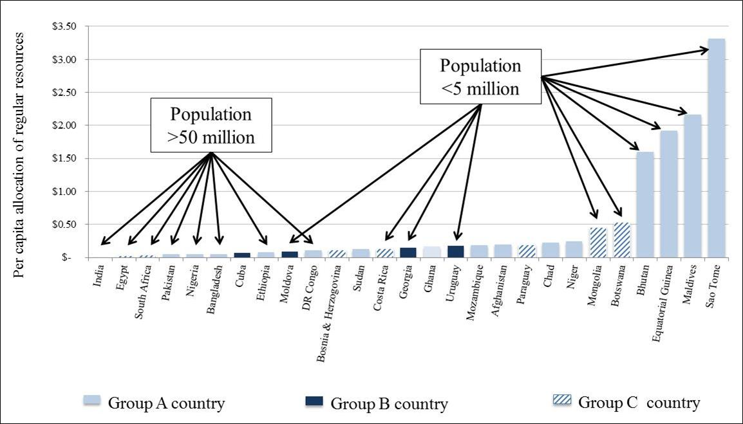

- There are 23 countries that receive more than $0.35 per person per annum, all of which have fewer than 5 million people. In contrast, countries with large populations receive only pennies per capita, despite being the countries that have the largest numbers of maternal deaths and the most unmet need for contraceptives.

- Even among relatively small countries, there is a very pronounced skew toward the smallest countries, which trumps other metrics, such as those related to need or even RAS category. This can be seen most clearly by looking at a few examples, as in table 3.

Table 3: Examples of allocations to countries with small populations
 | Botswana | Chad | Paraguay
RAS category | B | A | B
Population | 1.9 million | 10.5 million | 6 million
Maternal mortality ratio | 180 | 1100 (highest in world) | 99
Contraceptive prevalence rate (modern) | 35% | 1.7% (lowest in world) | 70.1%
Income category | Upper-middle | Low | Lower-middle
Regular resources per capita | $0.54 | $0.24 | $0.20

- The consequences of this bias toward small countries are significant, as the aggregate effects are quite large. For example, although less than 5 per cent of the total population of countries in which UNFPA works live in countries with 10 million people or less, these countries receive 26 per cent of UNFPA regular resources. By contrast, countries with more than 50 million people account for 77 per cent of the total population of countries in which UNFPA works, but these countries only receive 31 per cent of regular resources.

- As a result, the countries that are confronted with the largest numbers of maternal deaths and the largest numbers of people with unmet need for modern contraception receive a disproportionately small fraction of UNFPA regular resources, as shown in figure 2.

Figure 2: Mismatch between need and resource allocation
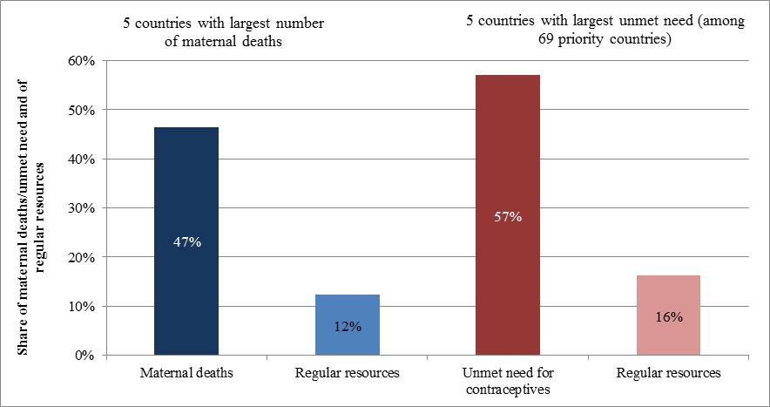

- These results are problematic from human rights perspective for an organization that has a universal mandate: women in large countries receive much less UNFPA assistance compared to those in small countries simply because they happen to live in more populous countries. However, there are a number of possible rationales for the skew toward small countries, and it is not necessarily appropriate that each country should receive an identical per-capita allocation of UNFPA resources.

- For example, the costs of programming in small countries could be systematically higher than the costs of programming in large countries (e.g., because of diseconomies of scale). The discrepancy could also be explained by a theory of change, which could explain that UNFPA can have more impact in smaller countries than in larger countries.

- The challenge currently, though, is that no such rationale underpins the skew toward small countries. This makes the bias particularly problematic, particularly for an organization such as UNFPA that considers human rights a key principle.

Allocation of resources not systematically connected to UNFPA interventions

- UNFPA programming is tailored to the settings in which it works, in response to the needs on the ground and the capacities present in partners. Thus, in Brazil and China, the organization’s work is primarily oriented to “delivering thinking”, such as through advocacy and policy dialogue and advice. In contrast, in a humanitarian crisis or in a setting with high need and low ability to respond, UNFPA is called upon to deliver a fuller range of interventions, from advocacy and policy dialogue and advice through knowledge management and capacity development to service delivery (particularly in humanitarian settings).

- UNFPA does not currently have a systematic way of describing its interventions in different settings, an issue that is being addressed in the context of a reexamination of the organization’s business model. However, this issue is also important for the RAS, because at the most basic level resources are being allocated to deliver a set of interventions. The amount of resources required to deliver a full package of interventions (including advocacy and policy dialogue and advice, knowledge management, capacity development, and service delivery) will obviously be different from the amount of resources required to deliver only advocacy and policy dialogue and advice.

- The natural corollary of this is that the allocation of resources should be based on the interventions to be delivered in a given setting. Currently, though, there is no connection between RAS and types of interventions to be delivered.

Current system not optimizing impact

- One of the essential functions of any system that allocates resources is to direct them to where they are likely to lead to impact. The UNFPA current system accounts for this to some extent by focusing on need in the selection of indicators and categorizing of countries, but it does not have a more structured mechanism for optimizing impact. For example, UNFPA resources are more likely to improve the lives of women, adolescents and youth if they are directed through high-performing country offices that have a track record of successful programming, but there is currently no systematic way to assess this and reward good performance. As a result, UNFPA does not channel increased resources to those countries that are able to make the best use of them.

Current system not well suited to humanitarian crises and other emerging threats and opportunities

- The world in which UNFPA works is highly unpredictable. Earthquakes or hurricanes can strike suddenly in areas that were previously calm and untroubled, while armed conflict can arise with little warning in countries that had been considered stable, as happened recently in Mali. Opportunities can also present themselves on short notice, whether as a result of political changes or technological breakthroughs.

- When either a humanitarian crisis or other threat occurs or when an opportunity emerges suddenly, UNFPA needs to be able to respond rapidly. At the moment, there are small pots of resources that can be used for humanitarian crises or new corporate projects, but they are considerably smaller (in both absolute and relative terms) than the amounts of money that both UNDP and UNICEF set aside before they divvy up the remainder through their equivalents of the RAS.

- The implication of this is that UNFPA is more heavily reliant on less predictable other resources in these situations. As a result, responding to humanitarian crises is more challenging, and the organization is less able to channel resources to innovative responses to emerging issues.

Leaving the current system unchanged except for updating indicator data would result in a challenging situation

- Despite the challenges listed above, it would be possible to leave the RAS unchanged and simply update country groups based on changes in the data associated with the eight indicators. However, it is important to understand that this approach would also lead to significant changes, as 22 countries would be slated to move between categories based on the latest data, as follows:
- From Group A to Group B: 5 countries;
- From Group B to Group C: 14 countries;
- From Group C to Group B: 3 countries.

- The revised number of countries and population shares that would result from these changes (assuming that the RAS is not modified in any other way) are shown in table 4.

Table 4: Changes to country groups based on shifts in data
 | 2008 |  | 2013
Group | Number of countries | Share of population | Number of countries | Share of population
A | 66 | 43% | 62 | 43%
B | 41 | 22% | 35 | 16%
C | 26 | 35% | 37 | 41%
Total | 133 | 100% | 134 | 100%

- The changes would be more pronounced for the countries moving from Group B to Group C, as the latter group is now considerably more crowded. Conversely, countries in Group B would stand to benefit considerably from the outflows to Group C, despite the fact that those countries that remained in Group B are not in any different state than they were in 2008, meaning that there is little evident rationale for significantly changing their resource allocations.

- This is made more problematic because of the nature of the threshold system. In some cases, changes so small as to be almost immaterial would have dramatic effects on the amount of money a country could receive. For example, the share of the youth population of Jordan increased by 0.4 per cent, which is just enough to enable it to cross a threshold. As a result, Jordan would move from Group C to Group B, which would have a significant impact of the volume of resources it could receive.

Addressing the challenges

- Responding to these challenges requires updating the RAS in a number of ways, as well as the introduction of other changes that are discussed in section IV of this annex.

- The proposed revision to the RAS will change the process that is used in the current system in several key ways. Figure 3 presents a high-level summary of the current and new processes.

Figure 3: Comparison of process flows between 2007 and revised RAS
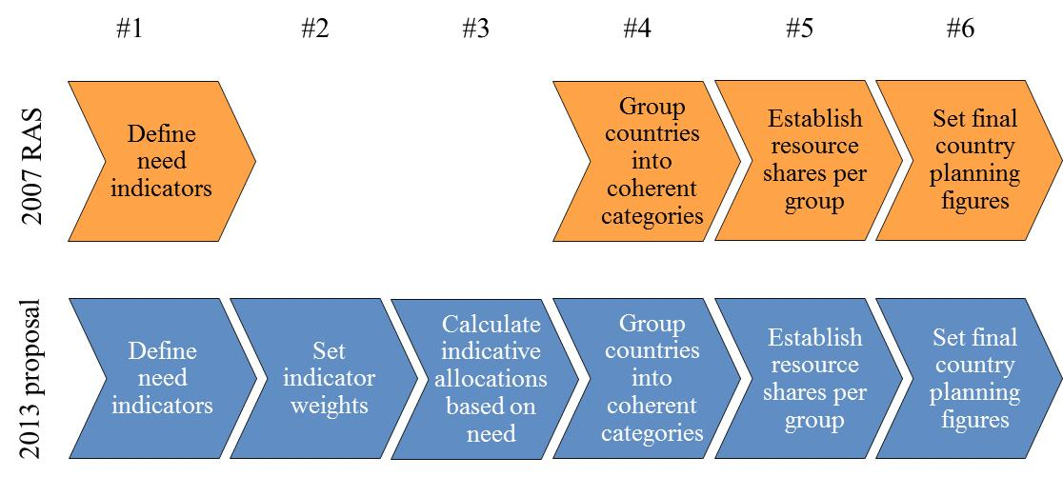

- Each of these steps is discussed in turn.

Define need indicators

- The countries in which UNFPA operates all need the organization’s support; indeed, there is no country in the world that does not confront challenges related to the implementation of some aspects of the ICPD Programme of Action. However, there are clearly large differences between the countries of the world when it comes to their need for UNFPA assistance: although Norway – which tops both the Human Development Index and the Gender Inequality Index – undoubtedly has some needs related to the ICPD agenda, there is little doubt that UNFPA can have more impact in Chad, which has the world’s highest maternal mortality ratio and one of the lowest contraceptive prevalence rates. This conclusion immediately leads to the question of how UNFPA can assess countries to determine how it can best achieve impact and advance the ICPD agenda.

- The process of selecting indicators to measure need was guided by several principles. To be considered for inclusion, each indicator needed to:
- Be directly relevant to the UNFPA strategic focus, as reflected in the bull’s eye;
- Be issued by a credible international source;
- Have sufficient country coverage;
- Contribute a unique dimension to the calculation of a country’s need (i.e., not duplicate another indicator).

- A number of indicators were screened based on these criteria, starting with the current set of eight RAS indicators, and ultimately a set of six indicators was identified. The new indicators are shown in Figure 4, along with a description of the changes from the 2007 set of indicators.

Figure 4: New RAS indicators, with a description of changes from current indicators
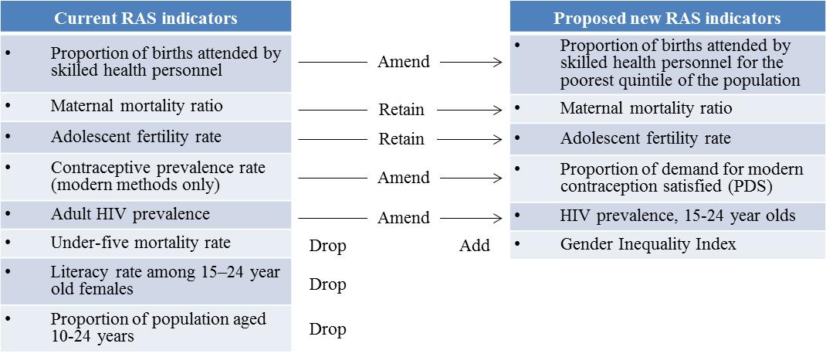

- In summary, two indicators from the current RAS have been retained unchanged, three have been amended, and three have been dropped, while one new indicator has been added. The rationales for the changes are as follows:
- Amendments:
  - Proportion of births attended by skilled health personnel (amended to focus on the poorest quintile of the population): this indicator will still be used, but will focus on the poorest quintile of the population rather than the entire population, to reflect inequalities within countries and the fact that UNFPA is concentrating its efforts on the poorest and most vulnerable. Data clearly shows that average performance on indicators calculated at the country level hide important disparities between groups. A recent study published in the Lancet, for instance, stratifies maternal and child health outcomes by wealth quintiles and finds that “Countries with similar levels of overall coverage often had very different results for equity.” Given that UNFPA is committed to focusing on the vulnerable, ideally the new RAS would use indicators that reflect the epidemiological status of the poor along every dimension of need, but sufficient data are not available to do so. Data are available, however, for proportion of births attended by skilled health personnel, so these are being used in the RAS. It is particularly important for this indicator because the same Lancet article found that the disparities by wealth quintile were more significant for this indicator than for any other eleven indicators studied;
  - Contraceptive prevalence rate (amended to proportion of demand for modern contraception satisfied: proportion of demand for modern contraception satisfied (PDS) is preferred to contraceptive prevalence rate (CPR) because PDS is both more meaningful and easier to interpret: PDS combines CPR and the unmet need for family planning rate into a single metric that provides a fuller picture of the contraceptive dynamics in a society, and also addresses a weakness in CPR, which is difficult to interpret since there is not an empirically well-defined maximum (unlike PDS, which can reach 100 per cent);
  - Adult HIV prevalence (amended to HIV prevalence, 15-24 year-olds): HIV prevalence will still be used, but will focus on 15-24 year-olds, both because young people are a key target audience for UNFPA and because this indicator is considered a reasonable proxy for HIV incidence, which is the ideal focus for an organization that concentrates on HIV prevention but which is difficult to measure directly. Additionally, this is the metric used in the Millennium Development Goals;
- Deletions:
  - Under-five mortality rate and literacy rate among 15-24 year-old females: these will both be dropped because UNFPA does not work directly on either of these issues (although the organization’s efforts may indirectly contribute to both of them). Moreover, these two indicators add no predictive value to the model, because they are extremely highly correlated with the existing indicators: the correlation coefficient between the scores of countries with and without female literacy rate (scored at 10 points) is 0.9955, meaning that the inclusion of this indicator makes no material difference to the RAS. The same pattern is seen with under 5 mortality (R² = 0.9942).
  - Proportion of population aged 10-24 years: population is an important variable, but including it in this way is problematic because there is not a normative direction associated with it (i.e., a higher or lower value is not intrinsically better or worse), unlike all of the other indicators in the RAS (for example, a decline in the maternal mortality ratio is normatively a good thing, as is an increase in the proportion of demand satisfied is normatively a good thing). However, with the share of the population aged 10-24 it is not possible to assign a directionality to changes: it is not intrinsically better for that number to be either higher or lower, which makes including the indicator problematic in a system that is otherwise based on clear indications of whether one value for an indicator reflects higher need than another value for the same indicator (i.e., a high maternal mortality ratio is unambiguously reflective of more need than a low maternal mortality ratio). Similarly, the work that UNFPA does is generally not about working with countries to either increase or decrease the percentage of the population aged 10-24, but rather about how to plan for the implications of whatever the figure is (and is likely to be in the years to come). This again is quite different from other indicators (e.g., UNFPA is working directly to support countries to reduce maternal mortality, rather than just to plan for the consequences of it), which also makes the inclusion of this indicator inappropriate. This should not be interpreted as indicating that the organization does not consider this an important area of work. Rather, population has been factored in separately, as discussed later;

- Additions:
  - Gender Inequality Index: this is a relatively new indicator included in the Human Development Report that provides a “composite measure of inequality in achievement between women and men in three dimensions: reproductive health, empowerment and the labour market”. Although UNFPA does not work directly on all of these areas, the indicator was selected over other possible metrics of gender equality for several reasons. First, it attempts to capture a holistic picture of the status of women in a given society, which is not the case for other indicators of gender equality. Second, it includes in its composition a number of areas on which UNFPA works directly, as well as some for which the causal pathways are indirect, unlike other contenders, where the causal pathways are solely indirect. Third, it reinforces the focus on inequality, which is a key element of the strategic plan more broadly. Last but definitely not least, it has good data availability, which is not the case for most other indicators related to gender equality.

- Each of the proposed indicators meets the criteria of having data for the majority of countries in which UNFPA operates and of coming from a credible international source, as follows.
- Proportion of births attended by skilled health personnel for the poorest quintile of the population: UNICEF, State of the World’s Children report 2013 (latest available data);
- Maternal mortality ratio: United Nations Statistical Division, MDG Database (2010 data);
- Adolescent birth rate: United Nations Population Division, World Population Estimates
- Proportion of demand for modern contraception satisfied: United Nations Population Division, World Contraceptive Use 2012 (2012 data);
- HIV prevalence, aged 15-24: UNAIDS Report on the Global AIDS Epidemic 2012 (2011 data);
- Gender Inequality Index: UNDP Human Development Report 2013 (2012 data).

- It will be noted that – as in the current RAS – there are no indicators that reflect the organization’s work on population dynamics and data. This is a function of two facts: first, every country has issues related to population and data, and second, there are not metrics that provide an easy to interpret summary of these and that have clear directionalities associated with them (unlike, for example, maternal mortality ratio, where a decline is unequivocally good). As a result, population dynamics and data issues are not factored into the calculation of need, although they are reflected in the mechanism of allocating resources, as described below.

- There are, however, two other topics that are proposed for inclusion as supplemental factors in the RAS:
- Risk for humanitarian crises: this is included because it is a factor that influences the ability of UNFPA to achieve impact, both by shifting the nature of the work that the organization carries out and by increasing the challenges (and thereby the costs) of delivering interventions; it is assessed through the OCHA Global Focus Model, which assesses the hazards facing countries, their vulnerability, and the capacity of populations to cope with risks;
- Income inequality: this is included because higher income inequality is typically associated with larger pockets of poverty, which shift the nature of UNFPA programming; it is assessed through the ratio of income of the poorest quintile to the richest quintile (from the UNDP Human Development Report 2013).

- These two have not been added to the list of six indicators above because they are not of the same nature: UNFPA directly works on the areas addressed by the six indicators, while these two supplemental factors are areas that affect the organization’s work but addressing them is not a core focus of the organization’s work (although there may be indirect effects, as, for example, efforts to promote gender equality may influence income inequality).

Set indicator weighting

- In the current RAS, all eight indicators are treated coequally. This is problematic because it implies that each is of equal importance for the organization, which is clearly not the case. Therefore, an additional step is proposed to be added to the RAS to weight the indicators.

- Several methodological approaches to combining indicators were explored. The approach ultimately settled upon is a simple, points-based system that assigns weights (points) first to each indicator (inter-indicator weighting) and then to levels of need within an indicator (intra-indicator weighting). This approach has commonalities with systems used by UNICEF and the Global Fund to Fight AIDS, Tuberculosis and Malaria.

- The choice of inter-indicator weights is not a strictly statistical exercise that can be based on existing empirical information. Instead, the weights should reflect strategic decision-making about the organization’s priorities. Figure 5 shows the weights for each of the six indicators listed above.

Figure 5: Weighting of RAS indicators
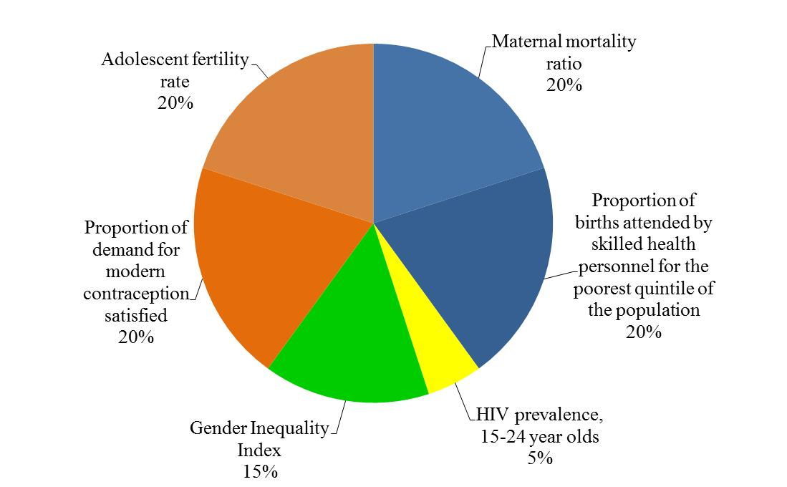

- This weighting reflects the focus of UNFPA efforts on sexual and reproductive health, adolescents and youth, and women, as reflected in the bull’s eye.

- These percentages reflect the maximum points awarded to a country that faces the highest need for a given indicator. For example, the country with the worst maternal mortality ratio in the world (Chad) receives 20 points. Naturally, countries that have a lower maternal mortality ratio receive a lower number of points on this indicator than Chad does. The number of points each receives is determined by what types of interventions UNFPA wishes to deliver in a country. The typology of interventions is described in greater detail in the Annex on the business model, as the proposed approach for the RAS builds directly on the conceptual framework set out in the business model:
- In the highest need settings, UNFPA often delivers a full range of interventions, from advocacy and policy dialogue/advice, knowledge management, and capacity development to service delivery;
- In high need settings, UNFPA generally does not focus on service delivery but will be involved in the other three programme strategies;
- In medium need settings, UNPFA typically concentrates on advocacy and policy dialogue/advice and knowledge management;
- In low need settings, UNFPA is generally focused solely on advocacy and policy dialogue/advice.

- These different modes of engagement determine the amount of points assigned for each need quartile: because UNFPA will deliver a full package of services in the highest need countries, countries in this quartile are assigned the maximum number of points for a particular indicator (in the case of maternal mortality, 20). Conversely, in high – as opposed to highest – need settings, UNFPA generally engages in all programme strategies except service delivery; since service delivery is expensive, removing this from the package of interventions reduces the number of points assigned to a country in high need. In the case of maternal mortality, these countries receive only 12 points. For countries with medium need and so receiving only advocacy and policy dialogue/advice, knowledge management, 6 points are assigned, while low need countries in which UNFPA is only engaged advocacy and policy dialogue/advice do not receive any need points (zero points are assigned because the basic capacity to handle advocacy and policy dialogue/advice is factored in elsewhere in the model, as described further below).

- Using this approach, each country in which UNFPA operates can be assigned a score, as in the examples in table 5.

Table 5: Examples of point-based system
 | Proportion of births attended by skilled health personnel for the poorest quintile of the population |  | Maternal mortality ratio |  | Adolescent birth rate |  | Proportion of demand for modern contraception satisfied |  | HIV prevalence, 15-24 year olds |  | Gender Inequality Index |  | Total points
Country | Quadrant | Points | Quadrant | Points | Quadrant | Points | Quadrant | Points | Quadrant | Points | Quadrant | Points
Botswana | Low | 0 | Medium | 6 | Medium | 6 | Medium | 6 | Highest | 5 | Medium | 5 | 28
Chad | Highest | 20 | Highest | 20 | Highest | 20 | Highest | 20 | High | 3 | High | 9 | 92
Yemen | High | 12 | Medium | 6 | High | 12 | High | 12 | Low | 0 | Highest | 15 | 57

- Finally, the two additional factors mentioned above – fragility and risk for humanitarian crises, and income inequality – are included by providing extra points. Thus countries that are considered to be facing the highest risks in the OCHA Global Focus Model receive an extra 10 points, while those facing high risk receive 6 points, and those with medium risk 3 points. Income inequality is scored in the same manner, with countries grouped into highest, high, medium, and low income inequality and receiving a sliding scale of points as a result, with 5 points the maximum. Table 6 provides an example of this.

Table 6: Examples of additional points
 | Fragility and risk for humanitarian crises |  | Income inequality |  | Additional points | Final points (combining previous points with additional points)
Country | Status | Points | Quadrant | Points
Botswana | None | 0 | High | 3 | 3 | 31
Chad | Highest | 10 | Medium | 1 | 11 | 103
Yemen | Highest | 10 | Medium | 1 | 11 | 68

- Countries are then assigned final need classifications based on their final point totals, with countries being split into quartiles (i.e., the quarter of countries with the highest scores are considered highest need).

Calculate indicative allocations based on need

- One of the challenges of the current RAS is that the percentage of resources going to each group of countries (the A, B, and C groups) is not based on any epidemiological or other criteria. Instead, it is primarily based on the earlier versions of the RAS.

- This is clearly not an ideal approach, and the points-based system for categorizing countries by need offers a significantly more robust way to determine the appropriate level of resources going to each group. The first step is to assess the volume of resources available for country programmes, based on income projections for 2014-2017 and the split of total resources available for country programmes. The second step is to remove from consideration resources that are set aside for other purposes (e.g., the Emergency Fund for humanitarian programming).

- Then, a minimum amount of money is set aside for programming in all countries. These resources constitute a “floor” that provide a foundation to enable country offices to carry out advocacy and policy dialogue/advice, and to engage on issues related to population dynamics and data. The floor is set at $500,000 per annum per country classified as low or lower-middle income by the World Bank, and $300,000 per annum per country classified as upper-middle or high income.

- However, this approach does raise an equity issue: some of the countries in which UNFPA operates are much more capable than others of providing resources to cover these basic costs themselves. UNFPA is currently not one of the growing number of multilateral institutions that requires some level of co-financing from the richer countries in which it operates. In an era in which an ever-increasing share of resources is being directed to the non-core part of the organization’s budget, this stance is increasingly untenable. Therefore, the approach is to benefit from the discussions that have occurred in the context of UNDP’s programming arrangements, in which agreement was reached that some countries should finance a portion of costs themselves.

- In particular, if countries that are classified as upper-middle or high income make contributions to their own country programme, UNFPA will match these on a one-to-one basis up to a further $100,000 (on top of the $300,000 floor). Therefore, if a country classified as upper-middle or high income provides a contribution from its domestic resources of $100,000, the total resources for the floor would be $500,000 (the initial $300,000, the contribution from the country of $100,000, and the matching UNFPA contribution of $100,000).

- The World Bank reclassifies countries each year. However, the 2013 classifications will be used for the purposes of calculating the expected contributions for the entirety of the strategic plan period.

- Once the resources for the floor are removed from the total available for country programmes, indicative individual country allocations can be calculated based on an initial assessment of the extent of programming that UNFPA is likely to undertake in a given setting. This is primarily a function of the mode of engagement in a given country: as explained above, a country in which UNFPA is carrying out a full package of services from advocacy and policy dialogue through to service delivery will on average require more resources than a country in which the organization is only doing advocacy and policy dialogue/advice.

- Therefore the need score from the preceding step is the starting point for the calculation. However, this must be adjusted for two factors that influence the extent of programming that UNFPA will carry out: the size of a country’s population and the ability of a country to finance its own programming. For population size, the indicator used is total female population aged 10-24. Although this is not the only target audience for UNFPA programming, the organization does put a particular emphasis on this group and so it is appropriate to use it as a population metric. For ability to finance, gross national income per capita (as reported by the World Bank, using the Atlas method) is used, with an average figure over the preceding three years used to avoid distortions from sudden swings in income.

- An additional step is required for the two multi-country island programmes in the Pacific and the Caribbean, for which existing country programme documents approved by the Executive Board, existing staffing, and anticipated changes in non-core contributions have been used for determining the indicative allocations.

- The resulting calculations produce indicative individual country allocations. However, to avoid disruptions to programming, the change to the RAS will only be phased in progressively. The transition will begin in 2015 for the small number of countries that have new country programme documents beginning that year, while for the majority of countries, the transition will only occur in 2016 to ensure that countries have adequate time to adjust.

Group countries into coherent categories

- The next step is to group countries together into categories that are coherent. In the current RAS, countries are grouped into categories A, B, and C. However, in the new RAS, the grouping will be linked to the business model, in which countries are split in colour quadrants based on the combination of need and ability to finance, as shown in Table 7. Determining the number of countries falling into each category is a simple process of combining the final need classification from step 2 above with the country’s income classification, which produces the results shown below. As additional information, the table also includes the share of the population living in countries in which UNFPA operates.

Table 7: Number of countries in each quadrant
 | Need
Ability to finance | Highest |  | High |  | Medium |  | Low
 | Number of countries | Share of population | Number of countries | Share of population | Number of countries | Share of population | Number of countries | Share of population
Low | 22 | 7% | 10 | 5% | 4 | 2% | 0 | 0%
Lower-middle | 8 | 5% | 16 | 28% | 12 | 8% | 9 | 4%
Upper-middle | 1 | 0.3% | 4 | 1% | 14 | 9% | 19 | 31%
High | 0 | 0% | 1 | 0.01% | 0 | 0% | 1 | 0.05%

- Thus in total there are 40 countries in the red quadrant (18% of total population), 21 orange (30%, or 11% if India is removed from the calculation), 16 yellow (9%), and 44 pink (44%, or 26% if China is removed from the calculation).

- The appendix to this document provides a list by quadrant of the countries in which UNFPA operates (including listing all of the countries contained in each multi-country programme), while the map below (figure 6) provides a visual depiction.

Figure 6: Map of UNFPA programme countries/territories by quadrant

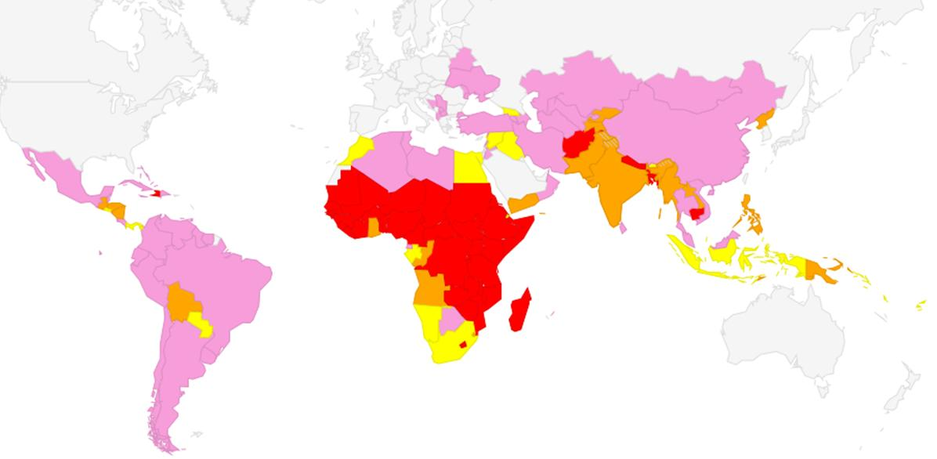

Establish resource shares per group

- As noted above, the current RAS does not have an underpinning logic for the volume of resources going to each group, other than that they are based on historical figures.

- The proposed approach creates a solid, evidence-based rationale for the split by colour quadrant. In this case, the determination of need described above drives the split of resources by quadrant, producing the resource shares shown in table 8. As noted earlier, the transition will only occur progressively, so different ranges are set for 2014-2015 and 2016-2017.

Table 8: Distribution of resources, population, and countries by quadrant
 | Share, 2014-2015 | Share, 2016-2017
Red | 50-52% | 59-63%
Orange | 21-23% | 20-22%
Yellow | 10-12% | 6-8%
Pink | 15-17% | 9-13%

- As in the current RAS, the approval from the Executive Board is in the form of ranges for each group of countries.

- The indicative allocations can also be used to provide a general sense of the resource allocation for other ways of categorizing countries, such as geographically or by income. It is important to stress that the following figures are indicative only, as the final breakdowns can only be determined based on the final planning figures for each country set by the Executive Board in the process of approving country programme documents (see below). In keeping with historical practice, the Executive Board is being asked only to approve a range of resources to be allocated to countries based on the color quadrants, rather than by geography or income.

- Figure 7 shows the shifting allocation by geographical grouping. The trend is to increase funding in those regions that are furthest from the attainment of the ICPD agenda, particularly Eastern and Southern Africa, and Western and Southern Africa. This trend is consistent with UNDP’s programming arrangements, although it is important to note that even by 2017, the indicative shares for other regions – particularly Asia and the Pacific, and Latin America and the Caribbean – will be higher for UNFPA than for UNDP.

Figure 7: Indicative allocations by region
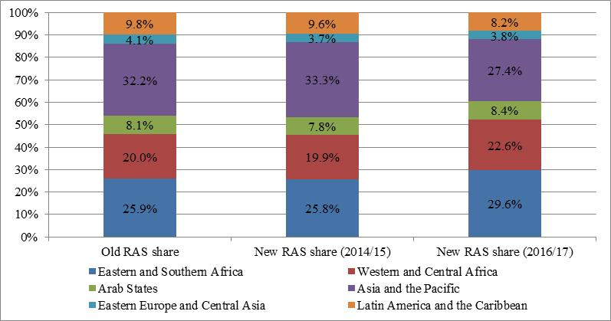

- Figure 8 looks at allocation by income category (as classified by the World Bank in July 2013), and figure 9 by whether or not a country is classified as least-developed.

Figure 8: Indicative allocations by income category
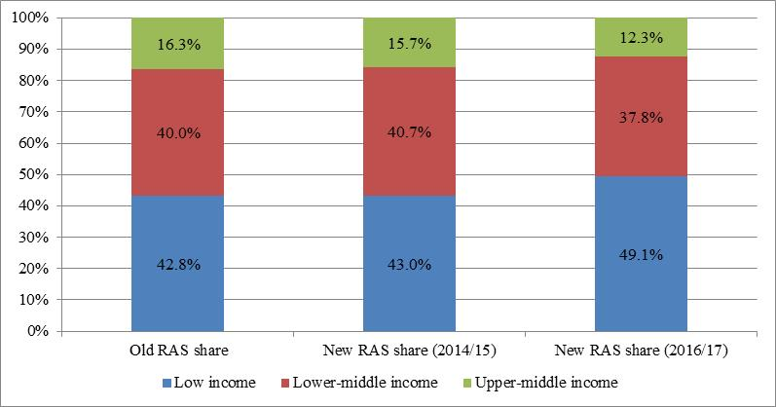

Figure 9: Indicative allocations by status as a least developed country
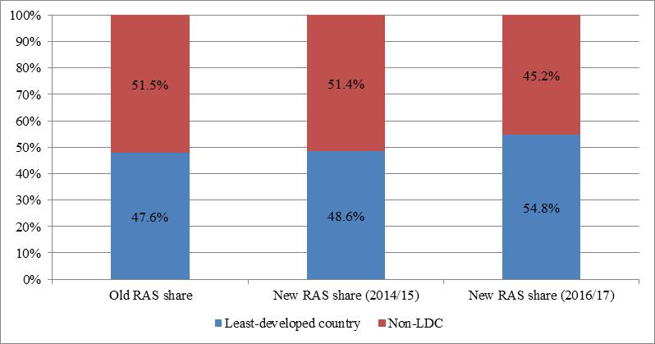

Set final country planning figures

- The final planning figures for each country are not set in the RAS. Instead, these figures are approved individually by the Executive Board in country programme documents. The planning figures for country programme documents are developed based on a flexible resource distribution system that takes into account local needs and priorities, including as manifested in United Nations Development Assistance Frameworks.

Other mechanisms for allocating programmatic resources

- The revision of the RAS will address many of the problems with the system described earlier. However, to fully respond to the key challenges outlined above, several additional elements are needed.

Emergency Fund

- In 2000, the Executive Board established an “Emergency Fund” to provide financing for the work of UNFPA in humanitarian settings. The annual allocation for the Fund was initially established at $1 million, which was increased in 2006 to $3 million. Each year, the Fund provides resources to countries facing crises based on the following criteria:
- Regular country programme funds are not available;
- Country programme funds are not immediately available but could be used at a later date for reimbursement with the approval of the government;
- Donor support for the UNFPA component of a Consolidated Appeal Process or Flash Appeal has been committed but funds are not yet in hand.

- In 2012, 16 countries received support from the Emergency Fund, 13 of which were suffering from floods or conflicts. The financing is primarily for sexual and reproductive health issues and to address gender-based violence, with the single largest item being the procurement of emergency reproductive health kits that are used to deliver services to women and girls who would otherwise not have access to this critical care as a result of humanitarian crises.

- Although the amounts disbursed from the Emergency Fund are not large, it nonetheless plays an important role because of the speed with which funds can be released: in 2012, the average time from submission of a request to the Emergency Fund to a reply was 1 day, down from 3 days in 2010. This enables the resources to be used catalytically, as well as providing a key stop-gap while other funding is being mobilized.

- The demands for UNFPA involvement in humanitarian settings have increased over time, but the Emergency Fund has remained capped at $3 million since 2006. An increase to $5 million – still far smaller than the equivalent fund at UNICEF – will enable UNFPA to respond more robustly to humanitarian crises and meet the needs of some of the most disadvantaged and needy populations.

Opportunities Fund

- The second additional mechanism is the Opportunities Fund, which is being established to strengthen the organization’s performance by supporting innovative new approaches. Several factors are driving this. First and foremost, progress on Millennium Development Goal 5 is lagging behind other MDGs, and one reason is that the global community has not yet identified optimally effective (and cost-effective) interventions to improve maternal health. This is particularly the case for reaching adolescents (particularly young girls), vulnerable and marginalized populations such as indigenous people, ethnic minorities, migrants, sex workers, persons living with HIV, and persons with disabilities.

- Second, UNFPA is operating in an environment of scarce resources that require the organization to demonstrate that it is a leader in pioneering innovative approaches to addressing its mandate. Rapid societal and technological changes present considerable opportunities to do this, but the organization must have a culture and systems to support innovation.

- Third, the organization has historically underinvested in innovation. By way of comparison, UNICEF has invested considerable resources in the area, with dedicated staff members focusing solely on innovation and a growing portfolio of projects (e.g., see http://unicefinnovation.org/ and http://unicefstories.org/ for additional information).

- The Opportunities Fund will be a new instrument with two distinct but inter-related purposes that address these issues. It will act both as a funding mechanism and as a way to strengthen the culture of innovation throughout UNFPA.

- As a funding mechanism, the Opportunities Fund will support both innovations (whether in products, processes, partnerships, or programming) and emerging opportunities (such as related to a new global initiative or for countries that identify important opportunities to advance the ICPD agenda but do not have sufficient resources to address them). The allocation of resources to these will be done based on transparent criteria, which will be determined before the end of 2013.

- The resources that will be used to finance initiatives through the Opportunities Fund will come from non-core contributions.

- The mechanics of the Opportunities Fund will be designed to enable maximum participation of staff from across the organization in its decision-making, so as to strengthen the cultural change dimension of the Fund. A number of other organizations – including other members of the United Nations Development Group – have mechanisms that allow for flexible responses to emerging opportunities, and lessons will be taken from these in the establishment of the Opportunities Fund.

- One key issue in the establishment of the Opportunities Fund will be ensuring that it does not lead to further fragmentation in the organization’s funding architecture, given that this is already a challenge for the organization. To avoid this, both the governance and management of the Opportunities Fund, and the reporting related to it will be integrated into existing structures. A number of changes are currently being made to the management of resources at UNFPA (including those associated with global and regional programming and those with thematic trust funds), so a final decision about the most efficient and effective governance and management for the Opportunities Fund has not yet been made.

- Aside from the direct benefits of the initiatives supported, a key element of the Opportunities Fund is strengthening the culture of innovation at UNFPA. This will entail being intentional and strategic about taking risks, tolerating failures, and building mechanisms to learn more rapidly from new efforts.

Strengthening mechanisms to optimize resources across the organization

- UNFPA does not currently have any mechanism to optimize resources across the entire portfolio, such as by rewarding good performance. For example, there is not a systematic way for country offices that are demonstrating excellent results and that would be able to scale up their programming to receive additional support. Conversely, there is also not a mechanism that looks holistically at the performance of a country office to determine which need additional support, whether technical, operational, or programmatic.

- This is not in place largely because UNFPA does not currently have an objective way to assess the performance of country offices. Some tracking is currently being done, but this is largely of operational metrics and so cannot provide a comprehensive picture. However, developing such a system in a manner that is objective and fair is a complicated matter and requires information systems that are not fully in place at the moment. Therefore, it is not possible to operationalize such an assessment mechanism overnight, and it is anticipated that this will not be possible before 2014 (partially because of links to some information systems that are currently under development).

- Moreover, it is important that UNFPA collaborate with fellow United Nations organizations on this, particularly since the “Standard Operating Procedures for Countries Wishing to Adopt the ‘Delivering as One’ Approach” explicitly calls for the development of “common guidance on performance-based allocation criteria, including minimum standards”.

- Once the systems are in place to assess performance robustly, it will be possible to design mechanisms to optimize resources (such as by rewarding good performers), but this will not be possible before late 2014 at the earliest.

Benefits of the new approaches

- The new approaches to funding arrangements will address the five key challenges described earlier, as summarized in Table 9.

Table 9: Challenges with current RAS and ways in which new approaches address them
Challenge | Response
The indicators were developed prior to the current strategic direction set out in the midterm review of the strategic plan, and do not completely align with the strategic direction | The proposed revision to the indicators described above directly addresses this problem, and ensures that the RAS indicators are aligned with the strategic direction. Moreover, the introduction of weightings for the indicators further strengthens the linkages between the RAS and the strategic direction (and also creates a flexible mechanism that can be used over time as the organization’s strategic direction evolves).
The current resource allocation does not adequately focus on needs, which is particularly problematic for an organization that has a universal mandate and bases its work on human rights principles, including respect for each and every life | The proposal approach will improve the extent to which UNFPA’s resources are focused on needs. As shown in Table 9 above, countries in the Red quadrant will receive the largest share of resources, and the highest per capita allocations.  Additionally, the share of resources going to least-developed countries will increase, as will the share allocated to countries facing the highest risks for humanitarian crises.  However, the use of the “floor” will also ensure that all countries in which UNFPA operates have the minimum capacity to support the ICPD agenda.
The allocation of resources is not aligned to the types of interventions to be delivered by UNFPA | This problem is addressed by basing the RAS on the business model, and tying the weightings in the RAS directly to the types of interventions that UNFPA will deliver, as set out in the business model.
The current system does not allocate resources in a way that optimizes impact, such as by rewarding performance | As noted above, this issue will have to be addressed progressively, as UNFPA does not currently have a system that can objectively assess performance. Once this system is established, it will be possible to improve the extent to which allocations are based on performance.
The current system is not well suited to responding to humanitarian crises | The increase in the size of the Emergency Fund from $3 million to $5 million described above will directly address this issue.

- As a result, the new approaches will improve the UNFPA’s overall effectiveness and efficiency, resulting in increased benefits for the lives of women, adolescents, and youth across the world.

Appendix: Classification of Countries/Territories

Red Quadrant  (40 countries) | Orange Quadrant  (21 countries) | Yellow Quadrant  (16 Countries) | Pink Quadrant  (44 countries)
Afghanistan  Bangladesh  Benin  Burkina Faso  Burundi  Cambodia  Cameroon  Central African Republic  Chad  Comoros  Côte d'Ivoire  Democratic Republic of the Congo  Eritrea  Ethiopia  Gambia  Guinea  Guinea-Bissau  Haiti  Kenya  Lesotho  Liberia  Madagascar  Malawi  Mali  Mauritania  Mozambique  Nepal  Niger  Nigeria  Rwanda  Senegal  Sierra Leone  Somalia  South Sudan  Sudan  Togo  Uganda  United Republic of Tanzania  Zambia  Zimbabwe | Angola  Bolivia (Plurinational State of)  Cape Verde  Congo  Democratic People's Republic of Korea  Ghana  Guatemala  Honduras  India  Kyrgyz Republic  Lao People’s Democratic Republic  Myanmar  Nicaragua  Pakistan  Papua New Guinea  Philippines  Sao Tome and Principe  Swaziland  Tajikistan  Timor-Leste  Yemen | Bhutan  Djibouti  Egypt  El Salvador  Gabon  Georgia  Indonesia  Iraq  Morocco  Multi-country Pacific  Namibia  Palestine  Panama  Paraguay  South Africa  Syrian Arab Republic | Albania  Algeria  Argentina  Armenia  Azerbaijan  Belarus  Bosnia and Herzegovina  Botswana  Brazil  Chile  China  Colombia  Costa Rica  Cuba  Dominican Republic  Ecuador  Equatorial Guinea  Iran (Islamic Republic of)  Jordan  Kazakhstan  Kosovo  Lebanon  Libya  Malaysia  Maldives  Mauritius  Mexico  Mongolia  Multi-country Caribbean  Oman  Peru  Republic of Moldova  Serbia  Sri Lanka  Thailand  the former Yugoslav Republic of Macedonia  Tunisia  Turkey  Turkmenistan  Ukraine  Uruguay  Uzbekistan  Venezuela (Bolivarian Republic of)  Viet Nam

According to DP-FPA/2010/1-E/ICEF/2010/AB/L.10 (“Joint report Road map to an integrated budget: cost classification and results-based budgeting”).
See section IV for more information about this.
The countries in the pink quadrant are those with the lowest need and highest ability to finance their own programmatic interventions (see section IV for more information about the classification). The reason that they are focused on in this context is that ROs are expected to play a particularly active roles in their countries, as the country offices themselves typically have fewer staff than the country offices in countries in the red quadrant, for example.
The change from 133 to 134 countries is due to creation of South Sudan.
This term is used throughout to refer to the states and territories in which UNFPA operates, which includes some territories that are not states and some multi-country groupings.
Barros et al (2012). Equity in maternal, newborn, and child health interventions in Countdown to 2015: a retrospective review of survey data from 54 countries. The Lancet, Vol 379, March 31, 2012.
Available at http://data.worldbank.org/about/country-classifications/country-and-lending-groups.
Figures do not add to 100 per cent because of rounding.
For these calculations, the multi-country programmes in the South Pacific and in the Caribbean are each counted as single countries because a single Country Programme Document is approved by the Executive Board for each of them. However, the specific contexts of each country/territory within the multi-country programmes will be used for determining the appropriate programming strategies that are most applicable for that country/territory. The multi-country programme in the South Pacific is in the yellow quadrant, while that in the Caribbean is in the pink quadrant. In both cases, the classifications were made by combining indicator values in a population-weighted manner, but using an unweighted approached produces the same results.
Cook Islands, Fiji, Micronesia (Federated States), Kiribati, Marshall Islands, Niue, Nauru, Palau, Samoa, Solomon Islands, Tokelau, Tonga, Tuvalu, and Vanuatu.
Anguilla, Antigua and Barbuda, Aruba, Bahamas, Barbados, Belize, Bermuda, British Virgin Islands, Cayman Islands, Curacao, Dominica, Grenada, Guyana, Jamaica, Montserrat, Netherlands Antilles, St. Lucia, St. Kitts and Nevis, Saint Maarten (Dutch Part),St. Vincent and the Grenadines, Suriname, Turks and Caicos, and Trinidad and Tobago.

