United Nations Population Fund

The UNFPA strategic plan, 2014-2017

Annex 3
Business model

Summary

This document presents annex 3 (which focuses on the business model) to the UNFPA strategic plan for 2014-2017. This annex examines the current issues with the “where”, “how”, and “who” of UNFPA work, and then describes the key features of the new business model.

Contents

Page

I. Introduction 3
II. Key issues with the current business model 5
- “What” 5
- “Where” 5
- “How” 6
- “Who” 8
III. Solutions 9
- “Where” and “How” 9
- “Who” 12
IV. Conclusions 15

Introduction

- This annex to the strategic plan, 2014-2017, covers the UNFPA business model. This term encompasses what impacts the organization seeks to achieve (including the beneficiaries of these changes), where the organization is going to achieve impact, how the organization will achieve impact (including the modalities of engagement), and who will enable the organization to achieve impact (i.e., what organizational structure and partnerships will optimize impact).

- Figure 1 provides a brief summary of the situation across these dimensions in 2013.

Figure 1: High-level summary of the current business model
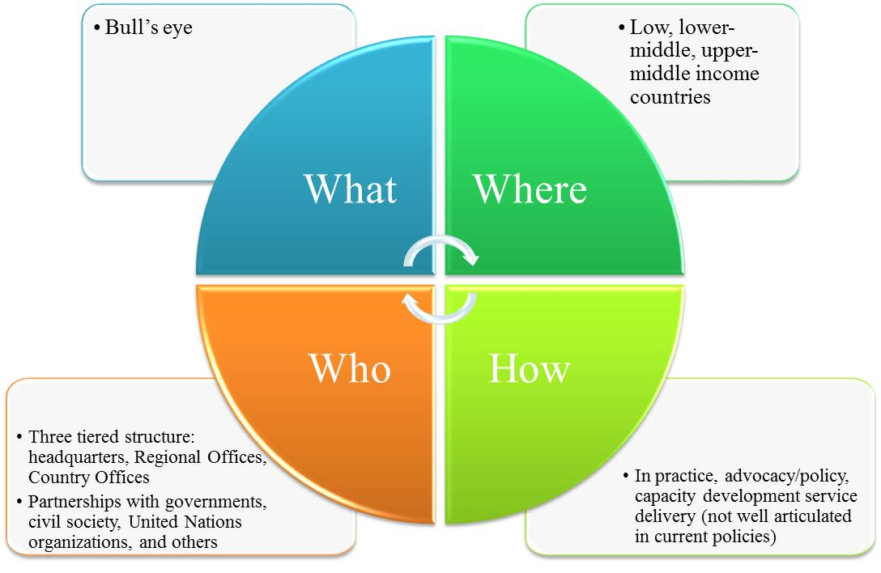

- The UNFPA business model has evolved since the organization was established, although this has primarily been through piecemeal efforts rather than a systematic initiative to look holistically at all of its elements. For example, a regionalization initiative begun in 2007 addressed some of the key aspects of the “who” dimension. The Resource Allocation System was revised at the same time, but it was developed separately from the regionalization process rather than in an integrated manner.

- The midterm review of the 2008-2013 strategic plan (MTR) addressed another major element of the business model: the what dimension. The MTR sharpened the organization’s substantive orientation by centering it on sexual and reproductive health and reproductive rights, and highlighting that the primary beneficiaries of UNFPA’s work are women and young people (including adolescents).

- Given this focusing, it is natural for the organization to re-examine the other elements of the business model, but there are also a number of other reasons – both external and internal – to do so:

- External factors:
  - First and most importantly, the Millennium Development Goal that UNFPA focuses most heavily on – MDG 5 A and B – is the furthest from attainment. Achievement of the MDGs is of course a shared responsibility, with countries themselves in the driver’s seat. However, the insufficient progress on MDG 5 must prompt some introspection in any agency that believes that it has an important role to play on maternal health. This poses a fundamental question to UNFPA: what can the organization do to ensure that it is best able to support the attainment of MDG 5, as well as the broader aspects of the ICPD agenda that it focuses upon?

  - Rapidly developing countries have different needs and so seek different support from UNFPA than was the case even a decade ago, and the organization has not fully adapted to this new reality. A number of countries – especially middle income ones – have unequivocally told UNFPA that it needs to operate in new ways if it wishes to remain relevant. In particular, these countries want the organization to focus on bringing high-level technical expertise and adding value through knowledge management (including by facilitating South-South Cooperation), and are much less interested in UNFPA being heavily involved in service delivery.

  - The third major external factor is the shifting distribution of poverty globally: in the words of one of the most cited authors working on the subject, “[i]n sum, the distribution of global poverty is thus: Half of the world’s poor live in India and China (mainly in India); a quarter of the world’s poor live in other MICs (primarily populous LMICs such as Pakistan, Nigeria and Indonesia); and a quarter (or less) of the world’s poor live in the remaining LICs.” This represents a major shift from three decades ago, when 90 per cent of the poor lived in low income countries. It is important to understand, though, that most of this change has come from a small number of populous countries moving into middle income status, and projections suggest that the share of poor people living in low income countries will rise in the coming years: “In 2020, global poverty is estimated to be split evenly between countries that are currently LICs and countries that are currently LMICs (in 2010). However, geographically, poverty is estimated to be focused in sub-Saharan Africa with 60-80 per cent of world poverty in that region of the world and the remainder largely in South Asia.”

- Internal factors:

  - First is the recognition that UNFPA does not currently have clear policy guidance on the different modes of engagement in different settings. The bull’s eye brought important clarity to the substantive focus of UNFPA work, and there is a corresponding need to be clear about how the organization operates. At the moment, there is little disagreement about the fact that UNFPA must operate in different ways in countries such as Brazil and China, on the one hand, and the Democratic Republic of the Congo and Haiti, on the other, and indeed in practice there is a lot of customization in national programmes. However, the organization does not have policy guidance that articulates these different types of engagement in a systematic way.

  - Second, UNFPA resources are spread quite thinly across the globe, which results in many countries having such small budgets that the only way that they can deliver results is by being focused and operating efficiently with strong back-up by a regional office, and so the business model needs to support this focusing.

  - Finally, the Quadrennial Comprehensive Policy Review, Delivering as One, and the broader UN reform process all highlight the importance of changing the way the UN does business to improve efficiency and effectiveness. Revisiting the business model is a key way that UNFPA can implement these UN-wide initiatives.

- Section II looks at each of the dimensions of figure 1 above in turn in an effort to respond to these external and internal factors. Section III details the solutions for the challenges identified.

Key issues with the current business model

“What”

- The substantive focus of UNFPA is captured by the “bull’s eye” diagram introduced in the MTR. This strategic direction has been assessed in the process of preparing the next Strategic Plan, and the conclusion is clear: both internal and external stakeholders are unambiguous about the importance of retaining the bull’s eye for the period 2014-2017. Even stakeholders who initially had concerns about it appreciate the fact it has helped the organization focus its efforts and so brought an important coherence to the organization’s work.

- Given these considerations – and the fact that the new strategic direction was only formally introduced in January 2012 and so needs some time to be validated – the strategic plan will continue with the same focus for 2014 to 2017. The language in the bull’s eye has been improved slightly, but no fundamental changes to it are proposed for the 2014-2017 period.

- The strategic plan document itself describes the substantive content associated with the strategic direction, and annex 1 (the integrated results framework) and Annex 2 (theories of change) contain supplemental details, so this annex does not focus on the bull’s eye.

“Where”

- UNFPA has a universal mandate, and so operates in countries across the world, as well as at both regional and global levels. This will remain the case for 2014-2017, but several specific issues need to be considered as the organization reflects on its business model:

- Middle-income countries: Given the global distribution of poverty, it is clear that UNFPA has an important role to play in countries across the world, including as they grow richer. While the nature of UNFPA work needs to shift as a country develops and so can take on a greater share of responsibility for financing and implementing interventions, there is no scenario in which UNFPA stops entirely working in middle-income countries over the period 2014-2017.

- Shifting areas of emphasis in middle-income countries: Although rapid growth in developing countries has had significant impacts on poverty and on the social and health indicators that UNFPA is particularly concerned with, these gains have not been shared equally across all socioeconomic strata, and UNFPA programming needs to address this fact, rather than taking an undifferentiated approach. UNFPA has to devote sufficient attention to understanding and responding to inequalities within countries, particularly middle income ones. Additionally, since middle- income countries increasingly have the fiscal space and internal capacity to make meaningful contributions to advancing the ICPD agenda – both nationally and through South-South cooperation with other developing countries – the roles that UNFPA plays and the type of programming that it does must shift.

- Ensuring that a broad footprint is financially sustainable: UNFPA currently operates programmatically in a total of 156 countries and territories (including all of the small island states that are part of regional multi-country programmes in the Pacific and in the Caribbean). By way of comparison, UNDP – which has a budget roughly five times as large as UNFPA – operates in 177 countries and territories. UNFPA has a universal mandate and is committed to a broad footprint, but operating in so many countries given the organization’s size inevitably poses some challenges, both operationally and particularly from the standpoint of financial sustainability.

“How”

- The “how” dimension of the business model was not a major focus of the MTR, but a number of issues emerged from the analytic work done in the preparation of the strategic plan and highlighted key elements that need to be addressed:

- Shifting demand for UNFPA’s services: As countries develop, they are less interested in having UNFPA involved in service delivery and more keen for the organization to add value through upstream work on advocacy and policy dialogue/advice. Figure 2 shows data from a large survey done in the context of the Quadrennial Comprehensive Policy Review (QCPR). The QCPR survey provides clear guidance on what countries are looking for from the UN system as a whole, with near unanimous support (across all income categories) for the UN system’s involvement in strengthening national capacity and training, and also high levels of interest in policy advice and in technical assistance (again across income lines, as seen in the two left-most categories above). However, there is much less interest in the UN getting involved in procurement or infrastructure development, and a clear pattern emerges by income grouping: relatively richer countries are even less interested in the UN involvement in service delivery. Additionally, countries – particularly middle-income countries – are increasingly asking that UNFPA assume a new role: that of the broker of expertise. The governments and technical experts in a number of countries in which UNFPA works are increasingly as sophisticated and capable as those anywhere in the world, and for UNFPA to add value in these contexts it must be able to bring in top calibre expertise. Historically, UNFPA has not focused on equipping itself with skills in brokering technical assistance, and the organization also must improve its ability to facilitate South-South and triangular cooperation, as there is little doubt that it will become a more important focus over the period 2014-2017.

Figure 2: Demand for different types of services provided by the United Nations
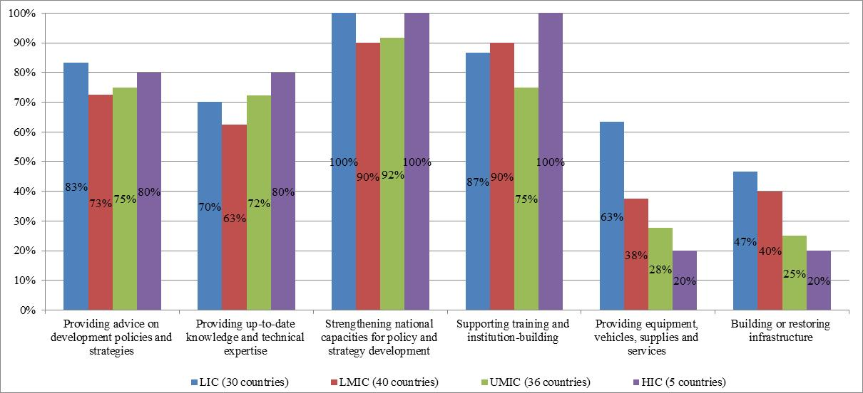

- Internal capacities of UNFPA: The organization is perceived to have its strongest comparative advantage in advocacy, followed by policy dialogue and service delivery. Conversely, capacity development and knowledge management were perceived as areas in which UNFPA is less strong. Given the importance of these areas – as seen in the figure above – this has clear implications for the organization’s efforts to develop its own internal capacities.

- Policy guidance: UNFPA currently lacks clear policy guidance on how it will achieve impact in different settings. Although the organization produces a number of technical guidance documents about the specific subjects on which it works, it does not currently have policies in place that cover how it should operate across the countries in which it works. There is broad recognition that the roles that the organization focuses on in an upper-middle-income country with a limited disease burden must differ from the roles in a low income country facing a sky-high maternal mortality ratio, but at the moment there is a dearth of policy guidance to help country offices determine the most appropriate programming strategies for their context. Although there are some important benefits to having such a flexible system, the absence of policy guidance means that UNFPA is too reliant on ad hoc solutions and on individual capacities and skills, instead of having a more systematic approach that would provide some rigor in the process of determining the most appropriate modes of engagement. This guidance, though, must preserve flexibility to respond to country needs and context.

- Humanitarian programming: UNFPA work on humanitarian programming has been strengthened by the adoption of the Second Generation Humanitarian Strategy. The organization has established a leadership role in issues related to sexual and reproductive health and reproductive rights, and gender-based violence, and is widely perceived as a leading advocate for women in emergencies. However, more attention should be given to the special needs of youth in crises, and the organization has yet to fully place the building of resilience at the heart of its work. Additionally, more work is needed to ensure that humanitarian response is mainstreamed throughout the organization, including through a clearer division of labour between headquarters, regional offices, and country offices. The final challenge relates to the resourcing of the humanitarian response, which involves both working with donors to ensure that the organization has adequate resources to meet the expectations of it, and also ensuring that the ways in which UNFPA manages its resources – both human and financial – are nimble enough to respond to humanitarian crises.

“Who”

- In thinking about who is responsible for delivering impact, it is important to understand that the UNFPA business model involves both internal and external actors:

- Internal actors: The most fundamental aspect of the “who” element of the business model is that the organization has a tripartite structure, with country offices, regional offices, and a global headquarters. As in any organization, there are a number of operational improvements that can be made in the workings of this structure, but only one more strategic issue emerged from the analysis:

  - Regionalization: The organization has historically had only country offices and headquarters, and much more recently introduced regional offices. The regionalization process has been rolled out over the course of the 2008-2013 Strategic Plan, and in many ways is still a work in progress. Regionalization processes are inevitably complicated and it is never possible to foresee all of the associated issues, and UNFPA’s experience is typical: some areas have worked well while others have proven to be more challenging. Unsurprisingly, questions have arisen about the respective roles and responsibilities of headquarters and regional offices, and the accompanying resources to implement on them. Another issue that has arisen is how to ensure that regional offices can become more strategic in providing support to country offices.

- External actors: Partnerships are at the heart of how UNFPA operates, and it is no exaggeration to state that the impact that the organization currently has is largely as a result of the strength of these partnerships, whether with governments, civil society, other UN organizations, academic institutions, the private sector, or others. As with internal actors, there are a number of operational issues related to how UNFPA works with partners, but also four more strategic ones:

  - Ownership of the ICPD agenda: Too often UNFPA is perceived as holding onto and trying to own the ICPD agenda. This is partially explained by the sensitive nature of the topics on which UNFPA works, and the accompanying fear that they will be abandoned if the organization is not their vocal champion. However, this approach makes it more difficult for some other actors to own the ICPD agenda.

  - Leveraging the UN system more effectively: Although the QCPR highlights the importance of the Resident Coordination (RC) function and the broader United Nations Development Assistance Framework (UNDAF) process as well as the UN reform agenda, including Delivering as One, UNFPA has not made optimal use of these to advance the ICPD agenda. This is a missed opportunity to mainstream work on the ICPD agenda across the entire UN system, which reduces UNFPA impact.

  - Private sector: As highlighted in the organization’s biennial partner survey, UNFPA receives far worse marks for engaging with the private sector than with any other set of stakeholders. Too often UNFPA engagement has been hobbled by a combination of an overly-narrow approach of looking at the private sector solely as a source of funds rather than also a repository of useful approaches and skills that can be employed to develop innovative solutions to problems that UNFPA is grappling with, and of a scepticism toward entities that operate in fundamentally different ways and based on different motives than UNFPA does.

  - Regional entities: Regional entities are playing increasingly important roles as economic and social power shift in a more globalized world. These institutions can be play important roles in advancing the ICPD agenda, as witnessed in the African Union’s Campaign on Accelerated Reduction of Maternal Mortality in Africa. UNFPA has increased its engagement with regional actors in some contexts, but this has not occurred systematically.

Solutions

“Where” and “How”

- The issues described above under the “where” and “how” elements of the business model are closely related, and so will be addressed in an integrated manner. The scheme shown in table 1 below is the key starting point for addressing a central element of this: establishing clarity on the programming strategies that UNFPA should use in different settings – or “how” and “where” it should operate. The interventions that UNFPA delivers across the globe can be grouped into a limited number of programming strategies:

- Advocacy and policy dialogue/advice: Upstream work involving rights-based support for and provision of recommendations regarding a course of action.

- Knowledge management: Activities related to the generation, analysis, use and sharing of knowledge intended to improve programmes through various means.

- Capacity development: The process by which skills, systems, resources and knowledge are strengthened, created, adapted and maintained over time in order to achieve development results.

- Service delivery: Involvement in the direct provision of goods and services to beneficiaries. For UNFPA, this category covers both direct delivery of services (such as procurement and behaviour change communications campaigns) and support of such delivery.

- More details on each of these are contained in annex 2 to the Strategic Plan on the theories of change. Several tools are employed across multiple programming strategies and so do not show up as their own categories. For example, UNPFA is engaged in partnerships in each of the above strategies, such that it has partnerships with civil society organizations for advocacy purposes, partnerships with academic institutions for knowledge management, and partnerships with governments for service delivery. The same is true of technical assistance, which is a tool used in each of the strategies above.

- Another cross-cutting way of delivering these programming strategies is South-South and triangular cooperation, an area of upstream work in which UNFPA plans increased involvement. The evolving global landscape creates new opportunities to assist programme countries by linking them with other programme countries that have relevant lessons learned, and UNFPA has an important role to play helping match countries that have experiences to offer advancing the ICPD agenda with those that could benefit from support. Therefore, South-South and triangular cooperation are also covered in detail in annex 2.

- It is clear that the deployment of these different modes of engagement must be based on local conditions. Table 1 provides some guidance to country offices, and makes it clear that the way UNFPA engages in a country with the highest need and lowest ability to finance must be fundamentally different than how the organization approaches a country that has a lower level of need and a higher ability to finance its own interventions.

Table 1: Modes of engagement by setting

 | Need
Ability to finance | Highest | High | Medium | Low
Low | A/P, KM, CD, SD | A/P, KM, CD, SD | A/P, KM, CD | A/P, KM
Lower-middle | A/P, KM, CD, SD | A/P, KM, CD | A/P, KM | A/P
Upper-middle | A/P, KM, CD | A/P, KM | A/P | A/P*
High | A/P* | A/P* | A/P* | A/P*
A/P = Advocacy and policy dialogue/advice CD = Capacity development
KM = Knowledge management SD = Service delivery
* physical presence only in select countries

- This table is at the heart of the new business model, as it provides guidance for how UNFPA should engage in different country contexts. For example, in countries that have the highest needs and low ability to finance their own interventions (coloured red in the matrix above), UNFPA should be prepared to offer a full package of interventions, from advocacy and policy dialogue/advice through knowledge management and capacity development to service delivery. However, in countries with low need and high ability to finance their own programmes (coloured pink in the matrix above), UNFPA should focus on advocacy and policy dialogue/advice.

- This approach builds on a number of key concepts that were introduced in the MTR, such as not trying to do everything everywhere and responding better to the changing needs of UNFPA clients. It also provides a tangible reality to the calls in a number of settings – including the QCPR and the broader UN reform agenda – for the entire UN system to shift away from “delivering things” to “delivering thinking”, or moving more upstream to focus on advocacy and policy dialogue/advice rather than service delivery.

- The matrix in table 1 is intended to be used as a starting point for thinking critically about how UNFPA should engage in different settings rather than as a straightjacket. It cannot replace country-level dialogue about national priorities and needs, and so the organization will preserve the flexibility to respond to the diverse challenges encountered. For example, if a country office in the yellow band (which would normally be focusing on advocacy and policy dialogue/advice and knowledge management) in collaboration with national partners determines that the most effective way to achieve impact given the resources at its disposal would be via capacity development, then it simply needs to provide a justification in the form of a robust business case.

- For the new business model to bring the expected benefits, the deployment of UNFPA resources – both human and financial – must be aligned with it. The alignment of financial resources is covered in the annex on funding arrangements, so this section focuses on human resources.

- For example, countries in the red quadrant are frequently the most managerially complex environments. This will require a larger number of staff, including leaders who have proven track records of managing complicated programmes in challenging settings. Conversely, in countries in the pink quadrant, the work will focus on upstream engagement, which typically requires fewer staff but which necessitates a particular profile of staff who are able to advance the ICPD agenda through partnerships, negotiations, communications, and other skills associated with advocacy and policy advice/dialogue.

- To examine the potential changes in human resources, ideal staffing complements for each country setting were determined and a model was built to quantify the implications of the proposed changes, which revealed that it will be financially viable for UNFPA to realign its staffing to support the business model. Aligning staff to better respond to the demands that countries are making of the organization will improve the effectiveness of programming and better position UNFPA to promote the ICPD agenda and close the gap in attaining MDG 5.

- A few elements of this shift merit special mention. First, this approach will enable UNFPA to maintain a broad country presence despite the organization’s limited budget. The shifts to the business model will not alter this, and it is not envisaged that country presence will change considerably over the period 2014-2017. Second, this approach will shift the number of international representatives that the organization maintains in country offices. Currently, more than 30 countries have UNFPA country offices but do not have representatives who reside in the country (not including the nations and small island states of the multi-country programmes for the Pacific and the Caribbean). In these countries the organization hires talented national staff who are able to drive the work of advancing the ICPD agenda while being supported by representatives who are based in other countries. This model has demonstrated that it can work well and so will be expanded, particularly in countries in the pink quadrant, where the focus is on advocacy and policy dialogue/advice. The role of the regional offices will also increase in these countries, as discussed in greater detail below.

- This transformation will not take place in a single big-bang; rather, the readjustment to the business model will be phased in over the first two years of the strategic plan, with new Country Programme Documents expected to reflect these programming strategies from the outset and existing country programmes gradually realigned, such that they are all aligned by the beginning of 2016.

- The changes described above will address most of the issues identified earlier in this Annex, with one notable exception that requires a separate approach: humanitarian programming.

- UNFPA has taken a number of steps to strengthen its humanitarian programming in recent years, including by launching a Second Generation Humanitarian Response Strategy, rolling out tools such as the “standard operating procedures” and “fast-track procedures”, and strengthening the organization’s internal capacity on humanitarian programming, such as by creating dedicated posts in regional offices and developing a surge roster. Over the course of 2014-2017, a number of further improvements will be launched to address key aspects of the organization’s humanitarian programming, both in terms of its external engagement and its internal resourcing and management.

- In terms of external engagement, although the Second Generation Strategy highlights the importance of preparedness, this has not yet become a major focus of the organization. To position preparedness at the heart of UNFPA work – in line with the focus on preparedness in the Inter-Agency Standing Committee’s Transformative Agenda and the QCPR – the organization will work with national authorities in select high-risk countries to ensure that the sexual and reproductive health and reproductive rights needs of women, adolescents and youth are adequately addressed in preparedness and contingency plans. One key element of this will be to use UNFPA comparative advantage in data analysis to ensure that planning is being done based on up-to-date, disaggregated data that enable vulnerable areas and populations to be identified in advance of crises. This effort will provide a key support to disaster risk reduction, as called for in the Rio+20 outcome document.

- A second shift in how UNFPA engages externally also relates to preparedness: the organization will build stronger partnerships with both UN agencies and local stakeholders that can ensure the delivery of assistance critical to maintaining the health and dignity of women in the event of a crisis. Organizations such as UNICEF and the World Food Programme have supply chain management expertise that is untapped at the moment, and in the event that UNFPA needs to evacuate a country but one or more partners can remain and operate, it is critical for the Fund to have already built the partnerships to ensure that these other organizations can ensure continuity of services.

- UNFPA is also re-examining its role in the humanitarian cluster coordination system. Since 2005 UNFPA and UNICEF have been co-leading the Gender-Based Violence Area of Responsibility. After consultation with UNICEF and other partners, UNFPA is now stepping up its leadership here.

- Internally, the organization is taking a number of steps to improve its ability to do humanitarian programming. One bottleneck at the moment is financial resources, as the Emergency Fund that is dedicated to humanitarian programming is quite small at $3 million per year. This is discussed further in annex 4 on funding arrangements.

- As part of the regionalization process embarked upon in 2008, direct support for humanitarian programming was supposed to shift from headquarters to regional offices. The Second Generation Humanitarian Response Strategy reinforces this in its emphasis on mainstreaming. However, regional offices have not been staffed to handle this and so support has been suboptimal. New posts for support to humanitarian programming at the regional level are being included in 2014-2017 integrated budget.

- Another important shift in the organization’s approach relates to the distinction between humanitarian and development programming. This is often a false dichotomy, and the organization needs to become more flexible in the use of its programme resources to meet the needs it is encountering. For example, countries facing prolonged humanitarian crises may be unable to spend “development” resources because of the operating environment but have nonetheless been slow to shift these resources to humanitarian efforts. Becoming less rigid in the distinction between the two will enable the organization to operate more effectively, particularly in prolonged humanitarian situations.

- Finally, to ensure optimal mainstreaming of humanitarian work, an internal cluster on humanitarian issues is being established. UNFPA has used internal clusters to ensure that the organization’s support is aligned in two key areas – women’s reproductive health, and adolescents and youth – and the lessons learned from these will be applied in establishing a new cluster on humanitarian programming.

- Together, these initiatives will strengthen UNFPA humanitarian programming and thereby its broader contribution to the human security agenda.

“Who”

- The responses to the issues identified earlier under the “who” element fall into two main categories: improvements to the regionalization process, and the strengthening of partnerships.

- As noted above, regionalization is very much still a work in progress. The most recent step in this – the creation of a second regional office for Africa, in Dakar, Senegal – is literally still being rolled out at the moment. A review of the process to date has been undertaken and had three key findings:

- Regionalization is not delivering its full potential, as a result of four main issues related to roles and responsibilities, oversight and quality assurance, human resources, and engagement with regional entities.

- The coming shifts in the business model at country level will necessitate changes in how the Regional Offices function.

- The purpose of regionalization was not always clear across the organization, and the rollout plan from the outset of the process in 2008 did not build in sufficient communications or adequate metrics to track its progress.

- To address these issues, a number of steps will be taken. One of the most critical is revisiting the roles and responsibilities of the regional offices and clarifying the division of labour with headquarters. Broadly, country offices will be responsible for implementing programmes, regional offices for providing support and quality assurance to country offices (including by facilitating South-South cooperation) and engaging with regional entities, and headquarters for providing normative guidance (including the development of tools, guidelines, and standards), providing quality assurance in critical areas (such as around regionalization), and engaging in global advocacy and intergovernmental policy dialogue.

- One important element of this relates to the shifting nature of support requested from a number of the countries in which UNFPA is working, particularly those that are now middle income. Many of these countries are now looking to UNFPA to bring in cutting-edge expertise that can engage in high-level technical debates with local experts on very specific topics of particular interest to the countries. The old model of UNFPA staff – whether in headquarters or in regional offices – directly providing that support is not feasible, as the demands from countries have been so specialized that they can only be met by bringing in top-flight experts in the particular subjects under discussion. This requires UNFPA to shift from direct provision of support to playing more of a brokering role, which often entails building relationships at regional levels with academic institutions, think-tanks, and other civil society partners. This shift will require a change in mindset as well as some adjustments to the skill sets possessed by UNFPA staff.

- Another key step in strengthening regionalization will be to improve the quality assurance function of regional offices. The introduction of a “programme review committee” at headquarters to review country programme documents before they are submitted to the Executive Board has significantly improved the quality of these documents, and this process contains important lessons learned that can inform the development of similar structures at the regional level. Strengthening the quality of the country programme action plans will be an important push over the period 2014-2017.

- A third shift related to regionalization will be the strengthening of human resources management. At the moment, this function is under-resourced at the regional level, limiting the ability of regional offices to provide strategic guidance or oversight to country offices in the area of human resources. The organization has a vacancy rate that impacts the ability to deliver, and strengthening the human resources function at regional level will be an important step to addressing this.

- The fourth key explanation for why regionalization has not reached its full potential stems from the fact that the world within which UNFPA operates is shifting constantly, and one key dynamic that the organization must adjust to is the rise of regional groupings. UNFPA has had notable successes in collaborations with regional entities (such as with the African Union on CARMMA), but to date too much of the organization’s work with regional entities has been ad hoc. Engaging more strategically with regional bodies will be a focus in the period 2014-2017.

- The changes in the UNFPA business model at country level will necessitate new approaches at the regional level. For example, if the staffing of countries in the red quadrant is strengthened, they will be more autonomous and so are likely to need less support from regional offices. Conversely, countries in the pink quadrant – many of which are increasingly sophisticated upper-middle-income countries – will benefit from the increased engagement of regional offices, which can broker the sort of highly specialized expertise they are seeking and who can facilitate South-South and triangular cooperation. This means that there will not be a one-size-fits-all model of the role of regional offices, since they must be responsive to the conditions and needs of the countries in their region.

- The second main response relates to partnerships. Partnerships are central to the work of UNFPA, but at times the organization’s zealous efforts to advance the ICPD agenda have led others to perceive that it is holding into the agenda too tightly, resulting in other organization not fully owning it. The organization needs to create a broader constituency for the ICPD agenda by letting go of it, and instead helping others internalize the relevant aspects of the ICPD agenda and embrace them fully, rather than setting them on the side as issues that only UNFPA handles.

- Doing this will require a more strategic approach to partnerships than is currently the case. The combination of the broad geopolitical and socio-economic shifts in the world with the wealth of new evidence being generated through the 2014 review of the ICPD agenda creates an ideal moment for the organization to take a step back and rethink its approach to partnership, and develop an organization-wide strategy for partnerships.

- Similar approaches are necessary at both regional and country levels, where partnership plans could help the organization become more strategic about how it sets loose the ICPD agenda, and reinforces its collaborative advantage. Although collaboration with traditional partners from governments, civil society, and other UN organizations will feature prominently in the partnership plans, introducing these plans will also help country and regional offices engage better with a new set of stakeholders, such as new geopolitical groups and the private sector. Several initiatives have begun with the private sector and are showing promise, such as a collaboration with Intel on midwifery education. UNFPA will expand what works and strengthen the culture of engagement with the private sector, so that it is looked to as a source of new ideas and approaches that can advance the ICPD agenda rather than simply a source of financing.

- Another important aspect of the work on partnerships relates to the broader UN development system. UNFPA is an active supporter of Delivering as One, and will expand joint programming efforts, as well as efforts to harmonize business practices and generally to improve efficiency of UN operations. Collaboration in the development of the strategic plans of UNDP, UNICEF, UN-Women, and WFP will facilitate efforts at the country level, as, for example, common approaches to results measurement and shared indicators have been agreed upon between the organizations.

- To improve clarity around the division of labour with other UN organizations, the theories of change contained in annex 2 provide further information about the specific collaborations with different organizations around key programmatic areas.

- The final element related to partnerships is the collaboration with implementing partners. UNFPA has made strides in reducing the fragmentation that has characterized its work with implementing partners, which will be continued in a way that is consistent with a broader emphasis on building national capacity rather than substituting for it. This means that the organization will reemphasize national execution as its preferred modality.

Conclusions

- The changes described in this Annex are significant and will require organizational focus and discipline to be implemented successfully. Learning a lesson from something that could have been done better in the roll-out of regionalization, the process of introducing the new business model will need to be monitored closely, so several indicators have been included in the integrated results framework for this purpose. Attainment of the targets set therein will have important benefits for UNFPA overall effectiveness and efficiency, and thereby its ability to improve the lives of women, adolescents and youth across the world.

Andy Sumner, “Where Will the World’s Poor Live? An Update on Global Poverty and the New Bottom Billion”, Center for Global Development, 2012, p. 3. MICs: middle income countries; LMICs: lower-middle income countries; LICs: low income countries.
Ibid., p. 13
The criteria used for determining need and the ability to finance are described in detail in Annex 4 on funding arrangements, so are not addressed in this Annex.

